Chapter 4
Creating a User Interface
About This Chapter
In this chapter, you’ll learn how to use Microsoft ASP.NET controls to create a user interface for a multipage Web forms application. You’ll learn about different styles of Web forms, how to choose controls based on the tasks you want to perform, how to validate data fields, and how to navigate between the Web forms in your application.
Before You Begin
To complete the lessons in this chapter, you must:
- Be familiar with the basic elements of HTML
- Understand the life cycle of Web forms, as discussed in Chapter 2, “Creating Web Forms Applications”
Lesson 1: Using Controls
Controls are the tools for all of the tasks you perform on a Web form. They define the appearance of the form and provide a way to get information and perform tasks on behalf of the user.
Microsoft Visual Studio .NET includes two types of controls that you can use on a Web form and two ways to position those controls on the form. In this lesson, you’ll learn about these differences and how they relate to major programming tasks.
After this lesson, you will be able to
- Select a layout style for your Web form based on the type of application you are creating
- Explain the differences between server controls and HTML controls and select the appropriate type of control for a particular programming task
- Bind control values to data items, such as variables, in your application
- Create templates for controls that contain repeating items
- Write code to respond to user events on controls
- Receive files uploaded from a client and store them on the server
Estimated lesson time: 60 minutes
Selecting a Layout
When you draw controls on a Web form, you have two options for how those controls are arranged:
- Grid layout
This is the default. Controls are placed exactly where you draw them, and they have absolute positions on the page. Use grid layout for Microsoft Windows–style applications, in which controls are not mixed with large amounts of text. Pages using grid layout will not always display correctly in non-Microsoft browsers.
- Flow layout
This layout positions controls relative to other elements on the page. If you add elements at run time, the controls that appear after the new element move down. Use flow layout for document-style applications, in which text and controls are intermingled.
To set how controls are placed on a page:
- In the Design window, select the Web form.
- In the Properties window, select the DOCUMENT object.
- Set the DOCUMENT object’s pageLayout property to FlowLayout or GridLayout.
Figure 4-1 shows the difference between GridLayout and FlowLayout on a Web form. You use GridLayout for Web forms that have a fixed appearance. You use FlowLayout for Web forms that incorporate text and controls.
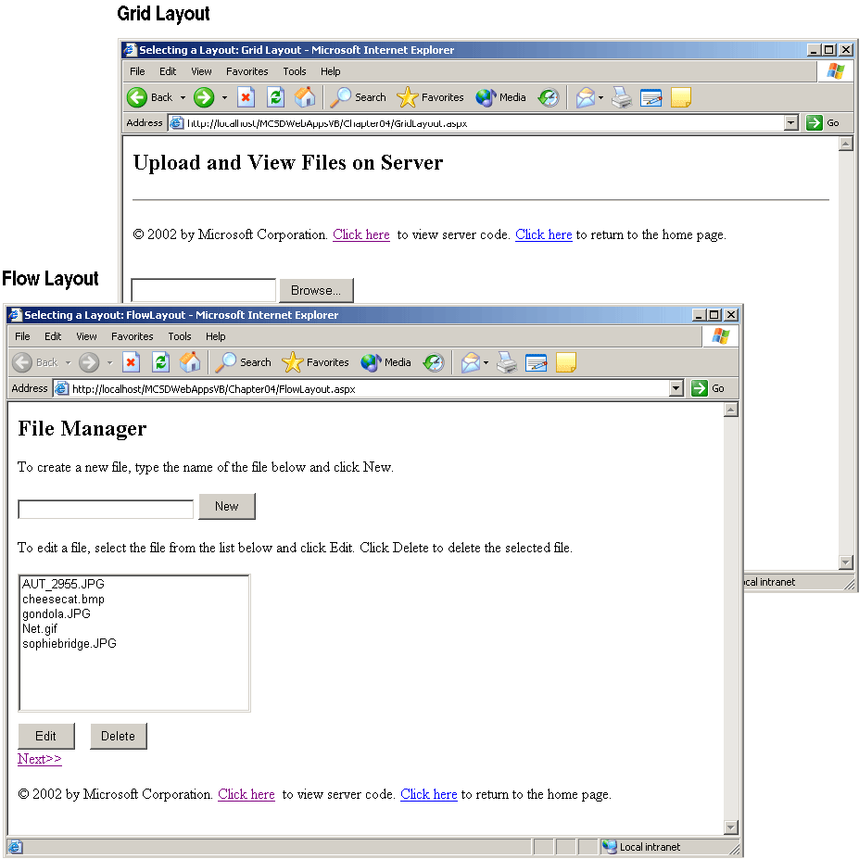
Figure 4-1. Selecting a layout
When you create controls with GridLayout, Visual Studio adds style attributes to each control that set the position of the control, as shown in boldface in the following form definition:
<form action="webform1.aspx" method="post"
enctype="multipart/form-data" runat="server" ID="Form1">
<h2>
Upload and View Files on Server
</h2>
<INPUT id="filUpload" style="Z-INDEX: 101; LEFT: 86px; WIDTH: 347px;
POSITION: absolute; TOP: 20px; HEIGHT: 27px" runat="server"
type="file" size="38">
<asp:Button id="butUpload" style="Z-INDEX: 102; LEFT: 357px;
POSITION: absolute; TOP: 60px" runat="server" Text="Upload"
Width="74px" Height="31px"></asp:Button>
<asp:ListBox id="lstServerFiles" style="Z-INDEX: 103; LEFT: 86px;
POSITION: absolute; TOP: 79px" runat="server" Height="140px"
Width="168px"></asp:ListBox>
<asp:Button id="butView" style="Z-INDEX: 104; LEFT: 268px;
POSITION: absolute; TOP: 178px" runat="server" Height="31px"
Width="76px" Text="View"></asp:Button>
<asp:Image id="imgView" style="Z-INDEX: 106; LEFT: 441px;
POSITION: absolute; TOP: 24px" runat="server"
Height="132px" Width="162px"></asp:Image>
</form>
When you create controls with FlowLayout, Visual Studio omits the style attribute. You can also create controls by double-clicking the control in the Toolbox, instead of using the drag-and-drop operation. Using FlowLayout makes it easier to mix controls and text on a Web form, especially when you’re editing the form’s HTML source, as shown in following form definition:
<form id="Form1" method="post" runat="server">
<h2>
File Manager
</h2>
<p>
To create a new file, type the name of the file below and click New.
</p>
<asp:Literal id="litNoFile" runat="server"></asp:Literal>
<asp:TextBox id="txtNewFile" runat="server" width="191px"> </asp:TextBox>
<asp:Button id="butNew" runat="server" Width="62px" Height="29px"
Text="New"></asp:Button>
<p>
To edit a file, select the file from the list below and click Edit.
Click Delete to delete the selected file.
</p>
<asp:Literal id="litNoneSelected" runat="server"></asp:Literal>
<asp:ListBox id="lstFiles" runat="server" Width="252px"
Height="161px"></asp:ListBox>
<br>
<asp:Button id="butEdit" runat="server" Width="62" Height="29"
Text="Edit"></asp:Button>
&nbsp;&nbsp;
<asp:Button id="butDelete" runat="server" Width="62px" Height="29px"
Text="Delete"></asp:Button>
</form>
Choosing the Right Control
You can use server controls or HTML controls on a Web form. What’s the difference? Basically, server controls are a superset of HTML controls and offer the advantages described in Table 4-1.
Table 4-1. Server Controls vs. HTML Controls
Feature | Server controls | HTML controls
Server events | Trigger control-specific events on the server. | Can trigger only page- level events on server (postback).
State management | Data entered in a control is maintained across requests. | Data is not maintained; must be saved and restored using page-level scripts.
Adaptation | Automatically detect browser and adapt display as appropriate. | No automatic adaptation; must detect browser in code or write for least common denominator.
Properties | The Microsoft .NET Framework provides a set of properties for each control. Properties allow you to change the control’s appearance and behavior within server-side code. | HTML attributes only.
So why use anything other than server controls? Because HTML controls have a one-to-one correspondence with standard HTML elements, they provide more direct control over what appears on a page. You use HTML controls for the following reasons:
- Migration from earlier versions of Active Server Pages (ASP).
You can load an ASP application into Visual Studio and revise it gradually, rather than rewrite it completely. Earlier versions of ASP supported only HTML elements, and these elements become HTML controls when you load the project in Visual Studio .NET.
- Not all controls require server-side events or state management.
This is particularly true when you’re doing data binding. Bound items are usually refreshed from the data source with each request, so it’s more efficient not to maintain state information for bound controls. This means that you can use HTML controls or turn off state management for bound server controls.
- You have complete control over what is rendered with HTML controls.
ASP.NET adjusts the appearance of server controls based on the browser making the request. HTML controls are not adjusted, so you have direct control over their appearance.
Server and HTML controls provide overlapping functionality. In general, it is easier to work with server controls. Table 4-2 lists the server controls and HTML controls by programming task.
Table 4-2. Server and HTML Controls by Programming Task
Task | Server controls | HTML controls
Display text | Label, TextBox, Literal | Label, Text Field, Text Area, Password Field
Display tables | Table, DataGrid | Table
Select from list | DropDownList, ListBox, DataList, Repeater | List Box, Dropdown
Perform commands | Button, LinkButton, ImageButton | Button, Reset Button, Submit Button
Set values | CheckBox, CheckBoxList, RadioButton, RadioButtonList | Checkbox, Radio Button
Display images | Image, ImageButton | Image
Navigation | Hyperlink | none (use <a> tags in text)
Group controls | Panel, Placeholder | Flow Layout, Grid Layout
Work with dates | Calendar | none
Display ads | AdRotator | none
Display horizontal rules | Literal | Horizontal Rule
Get filenames from client | none | File Field
Store data on page | (provided by state management) | Input Hidden
Validate data | RequiredFieldValidator, CompareValidator, RangeValidator, RegularExpressionValidator, CustomValidator,ValidationSummary | none (use page- level scripts)
The following sections describe the major programming tasks you perform with controls to create a user interface.
Working with Text
There are a lot of ways to display text on a page. For read-only text, you can write directly to the Response object, as in Response.Write(“Some text”); you can use a Label control; you can use a TextBox control and set its ReadOnly property to True; or you can use a Literal control and compose the text in HTML as you would with the Response.Write method.
To display editable text, however, you want to use a TextBox server control. The TextBox control has the key properties listed in Table 4-3.
Table 4-3. TextBox Control Properties
Property | Use to
Text | Get or set the data in the TextBox control.
TextMode | Display SingleLine, MultiLine (scrollable), or Password text. When set to Password, the text box displays dots in place of the characters typed.
ReadOnly | Prevent the user from changing the text.
AutoPostBack | When set to True, causes the TextBox control to fire a TextChanged postback event when the user leaves the TextBox control after changing the contents. By default, this property is set to False and the TextChanged event is cached until some other postback event occurs.
To see the text controls in action, perform the following steps to create a logon page:
- Start a new Web application with two Web forms named Webform1 and Webform2.
- On Webform1, draw Label, TextBox, and Button controls, and set their properties to the values shown in the following table:
Control | Property | Setting
Label1 | Text | Username:
Label2 | Text | Password:
TextBox1 | ID | txtUser
TextBox2 | ID | txtPassword
 | TextMode | Password
Button1 | ID | butOK
 | Text | OK
- Add the following code to the butOK_Click event procedure:
Visual Basic .NET
Private Sub butOK_Click(ByVal sender As System.Object, _
ByVal e As System.EventArgs) Handles butOK.Click
If txtUser.Text = "Guest" And txtPassWord.Text = "Moondog" Then
Response.Redirect("Text2.aspx")
Else
txtPassword.Text = ""
End If
End Sub
Visual C#
private void butOK_Click(object sender, System.EventArgs e)
{
if ((txtUser.Text == "Guest") &&
(txtPassword.Text == "Moondog"))
Response.Redirect("Text2.aspx");
else
txtPassword.Text = "";
}
- Run the application. When you enter the username and password specified in the code, Text2 is displayed, as shown in Figure 4-2. Notice that setting the TextMode property to Password causes each character entered to be replaced with a symbol.
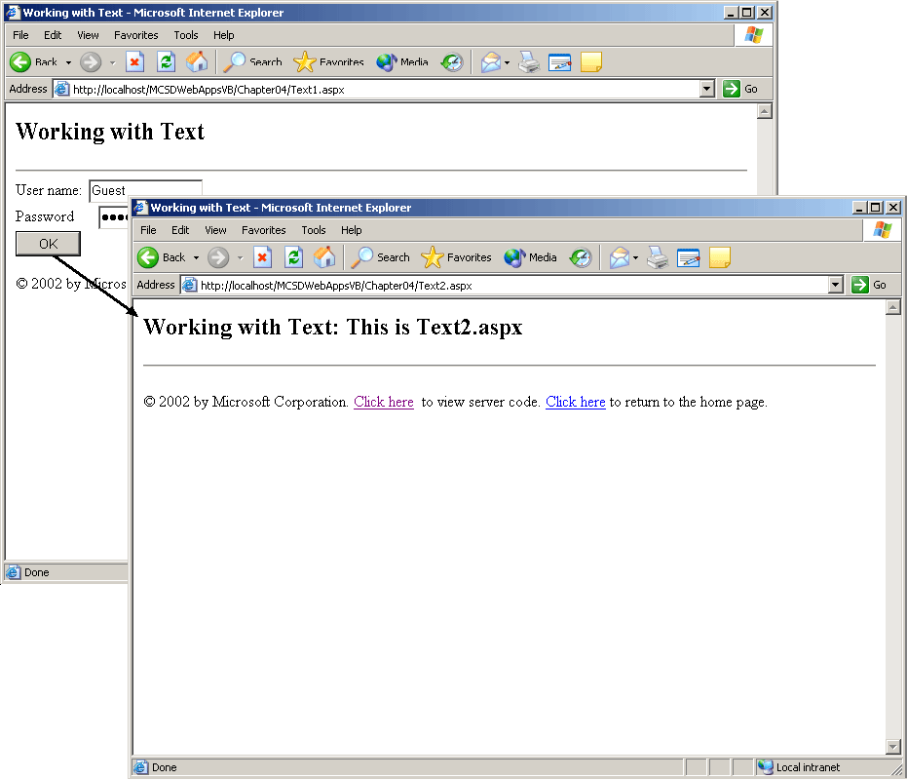
Figure 4-2. Web forms Text1 and Text2
Of course, it’s usually not a good idea to put passwords and usernames in code. Instructions on how to save and retrieve passwords from a secure file on the server are included in Chapter 8, “Maintaining Security.”
Working with Tables and Lists
Text displayed in Label and TextBox controls is arranged in a single block. To arrange text in rows and columns, you need to use one of the list or table controls described in Table 4-4. Use the ListBox, DropDownList, and Table controls for simple dynamic tables and lists. Use the DataGrid, DataList, and Repeater controls for complex tables and lists that contain other controls or are bound to data.
Table 4-4. ASP.NET List and Table Controls
Control | Use to
ListBox | Display read-only text in a simple scrollable list format.
DropDownList | Display read-only text in a simple drop-down list format.
Table | Display text and controls in columns and rows. Table controls allow you to dynamically build tables in code using TableRows and TableCells collections.
DataGrid | Display text and controls in columns and rows using a template to control appearance. DataGrid controls have built-in formatting, sorting, and paging capabilities.
DataList | Display rows of text and controls using a template to control appearance. DataList controls have built-in formatting and selection capabilities.
Repeater | Display rows of other controls using a template to control appearance. Repeater controls do not include the built-in capabilities found in the DataGrid and DataList controls.
Adding Items to a List or Table at Design Time
The ListBox, DropDownList, and Table controls allow you to add static items at design time using the Collection Editor dialog box, as shown in Figure 4-3.
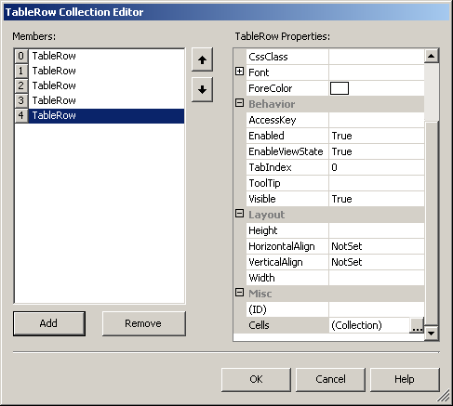
Figure 4-3. The Collection Editor
You use the Collection Editor to add static items to a ListBox, DropDownList, or Table control, as follows:
- To add static items to a ListBox or DropDownList control, select the Items property in the Properties window and click the button next to (Collection).
- To add static items to a Table control, select the Rows property in the Properties window and click (Collection).
Adding Items to a List or Table at Run Time
To add items to a list at run time, use the Add method of the control’s Items collection. For example, the following code adds items entered in a TextBox control to ListBox and DropDownList controls:
Visual Basic .NET
Private Sub butAdd_Click(ByVal sender As System.Object, _
ByVal e As System.EventArgs) Handles butAdd.Click
ListBox1.Items.Add(txtSource.Text)
DropDownList1.Items.Add(txtSource.Text)
End Sub
Visual C#
private void butAdd_Click(object sender, System.EventArgs e)
{
ListBox1.Items.Add(txtSource.Text);
DropDownList1.Items.Add(txtSource.Text);
}
Both the ListBox control and the DropDownList control automatically store the items you add to them at run time. The Table control, however, will automatically store data only for the table cells created at design time in the Collection Editor. To create additional table rows and cells at run time, you need to rebuild the table from information stored in a state variable. For example, the following code displays comma-delimited items entered in a text box as cells in a table, adding rows to the table each time the user clicks the Add button:
Visual Basic .NET
Private Sub butAdd_Click(ByVal sender As System.Object, _
ByVal e As System.EventArgs) Handles butAdd.Click
' Add text to the page's ViewState.
ViewState.Add(Viewstate.Count, txtSource.Text)
' Rebuild the table.
RebuildTable()
End Sub

Private Sub RebuildTable()
Dim iCount1, iCount2 As Integer
Dim arrWords As String()
Dim strWords As String
' For each string saved in ViewState...
For iCount1 = 0 To ViewState.Count - 1
' Create a new table row.
Dim rowNew As New TableRow()
' Get the string from ViewState.
strWords = ViewState(iCount1)
' Break item list into an array.
arrWords = Split(strWords, ",")
' For each item in the array.
For iCount2 = 0 To UBound(arrWords)
' Create a new table cell.
Dim celNew As New TableCell()
' Set the text to display in the cell.
celNew.Text = arrWords(iCount2)
' Add the cell to the table row.
rowNew.Cells.Add(celNew)
Next
' Add the row to the table.
Table1.Rows.Add(rowNew)
Next
End Sub
Visual C#
private void butAdd_Click(object sender, System.EventArgs e)
{
ListBox1.Items.Add(txtSource.Text);
DropDownList1.Items.Add(txtSource.Text);
// Add text to the page's ViewState.
ViewState.Add(ViewState.Count.ToString(), txtSource.Text);
RebuildTable();
}

private void RebuildTable()
{
string[] arrWords;
string strWords;
TableRow rowNew;
TableCell celNew;
// For each string saved in ViewState.
for (int iCount1 = 0; iCount1 < ViewState.Count; iCount1++)
{
char[] strSep = {','};
// Create a new table row.
rowNew = new TableRow();
// Get the string from ViewState.
strWords = ViewState[iCount1.ToString()].ToString();
// Break the item list into an array.
arrWords = strWords.Split(strSep);
// For each item in the array.
for (int iCount2 = 0;
iCount2 <= arrWords.GetUpperBound(0); iCount2++)
{
// Create a new table cell.
celNew = new TableCell();
// Set the text to display in the cell.
celNew.Text = arrWords[iCount2];
// Add the cell to the table row.
rowNew.Cells.Add(celNew);
}
// Add the row to the table.
Table1.Rows.Add(rowNew);
}
}
Getting the Selected Item from a List
Use the SelectedItem property to get the current selection from a list. For example, the following code displays the items selected from a list box in a label on a Web form:
Visual Basic .NET
Private Sub Page_Load(ByVal sender As System.Object, _
ByVal e As System.EventArgs) Handles MyBase.Load
' Test if there is a selected item.
If Not IsNothing(ListBox1.SelectedItem) Then
' Display the selected item.
Label1.Text = "The selected item is: " _
& ListBox1.SelectedItem.Text
Else
Label1.Text = "No item is selected."
End If
End Sub
Visual C#
private void Page_Load(object sender, System.EventArgs e)
{
// Test if an item is selected.
if (ListBox1.SelectedItem == null)
Label1.Text = "No item is selected.";
else
// Display the selected item.
Label1.Text = "The selected item is: " +
ListBox1.SelectedItem.Text;
}
If an item is selected, the SelectedItem property returns a ListItem object; otherwise, SelectedItem returns Nothing or null. Therefore, you should always check the value of SelectedItem before using the returned object’s properties.
Using Simple Data Binding with Lists
Controls can get their values from any data source in your application. Data sources can be any public data—whether the data is a database table, an array, a property of an object, or an expression combining several items. At its simplest level, data binding provides an easy way to initialize the values of ListBox and DropDownList controls on a Web form.
To see how simple data binding works, follow these steps:
- Create a Web form with a DropDownList control and the following code:
Visual Basic .NET
' Public data item for DropDownList.
Public arrData As String() = {"This", "that", "and", _
"the", "other"}

Private Sub Page_Load(ByVal sender As System.Object, _
ByVal e As System.EventArgs) Handles MyBase.Load
' Bind data to controls on this page.
Page.DataBind()
End Sub
Visual C#
// Public data item for DropDownList
public string[] arrData= {"This", "that", "and", "the", "other"};

private void Page_Load(object sender, System.EventArgs e)
{
Page.DataBind();
}
- Select the DropDownList control, and click the button in the DataBindings property in the Properties window. Visual Studio displays the DataBindings dialog box, as shown in Figure 4-4. You use the DataBindings dialog box to load items from any public data source to list or table controls.
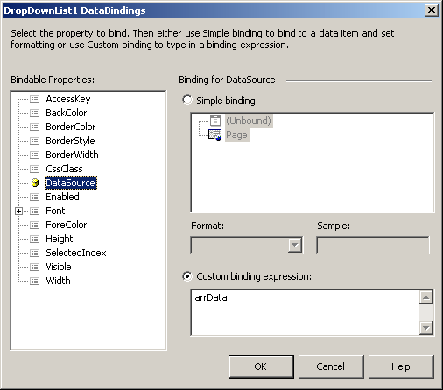
Figure 4-4. The DataBindings dialog box
- Select the DataSource property in the Bindable Properties list, and then select the Custom Binding Expression option button, type arrData in the expression box, and click OK. When you run the application, the items in the arrData array are displayed in the DropDownList control, as shown in Figure 4-5.
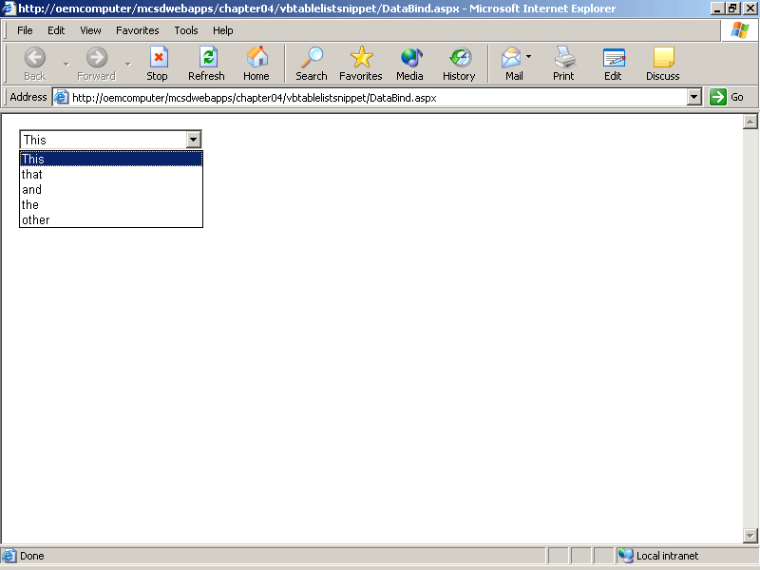
Figure 4-5. Binding a list control to an array
When you use data binding with a server control, you can turn off state management for that control. This improves performance because the DataBind method replaces the automatic view state management provided by ASP.NET.
To turn off state management for a server control, set the control’s EnableViewState property to False.
Adding Items to DataGrid, DataList, and Repeater Controls
Use data binding to add items to the DataGrid, DataList, and Repeater controls. These three controls use templates to define their appearance at run time. A template is a set of HTML elements or server controls, or both, that will be repeated for each data item in the control.
To add items to a DataGrid, DataList, or Repeater control, follow these steps:
- Define the data source.
- Draw the DataGrid, DataList, or Repeater control and bind to the data source.
- Edit the templates in the control to add HTML elements or server controls that will be repeated within the list or grid.
- Set the properties of the server controls contained in the list or grid to bind to data items in the container’s data source.
The following example shows how to add template columns to a DataGrid control and how to bind the controls in those columns to a simple data source:
- Create a public data source in your application as you did in the previous procedure. For example, the following code creates an array to demonstrate a simple data source:
Visual Basic .NET
' Public data item for DataGrid.
Public arrData As String() = {"This", "that", "and", _
"the", "other"}
Visual C#
// Public data item for DataGrid.
public string[] arrData = new string[] {"This", "that",
"and", "the", "other"};
- Draw a DataGrid control on a Web form.
- Add template columns to the control by selecting the DataGrid control and then clicking the Property Builder link at the bottom of the Properties window. Visual Studio displays the Properties dialog box, as shown in Figure 4-6.
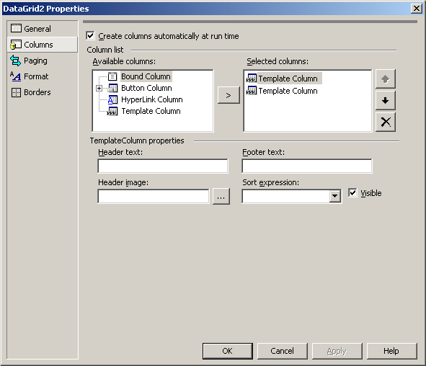
Figure 4-6. Properties dialog box
- In the Properties dialog box, select Columns, and then select Template Column in the Columns list and click the Add (>) button to add a template column to the DataGrid control. For this example, add two template columns and click OK.
- In the Properties window, select the DataSource property and specify the data source for the control. For this example, type arrData, the array created in step 1.
- Create the template used to display data in the control: right-click the DataGrid control, point to Edit Template, and select Columns[0] from the shortcut menu. The control’s appearance changes to Edit mode, as shown in Figure 4-7.
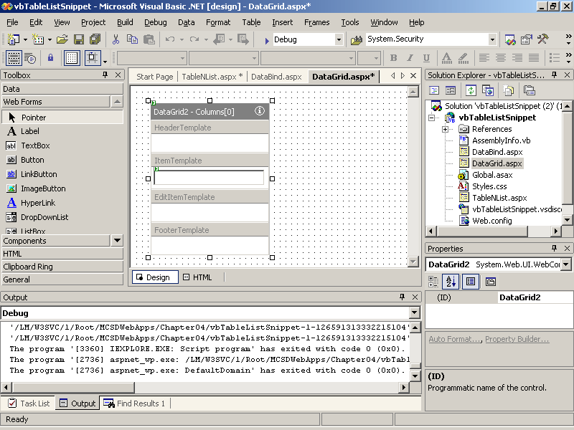
Figure 4-7. Adding controls to DataGrid
- Draw other controls on the Web form, and then drag them onto the template to add them to the DataGrid control. For this example, draw a TextBox control and drag it on to the template for column 0.
- In the Properties window, select the DataBindings property of the control you just added to the template, and click the button that appears. Visual Studio displays the DataBindings dialog box, as shown in Figure 4-8.
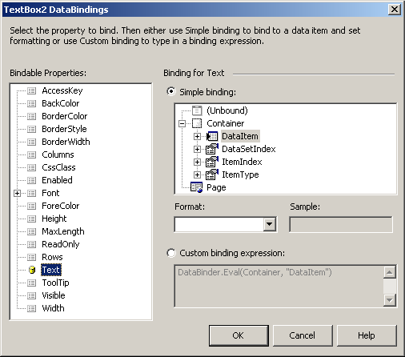
Figure 4-8. The DataBindings dialog box
- In the Bindable Properties list, select the property to receive the data item. For this example, select Text. Select Simple Binding, and then expand Container and select DataItem to specify which data item to put into the selected property. Click OK to close the dialog box.
- Edit the second template column. To do this, right-click the DataGrid control, select Edit Template, and then select Columns[1] from the shortcut menu.
- Repeat steps 4 through 7 for Column(1). For this example, draw a Button control and drag it onto the Column(1) template in the DataGrid control.
- Close the template when you’ve finished. To do this, right-click the template and select End Template Editing from the shortcut menu. Visual Studio displays the contained controls, as shown in Figure 4-9. To change any of the contained control’s properties, edit the template as we did in the preceding steps.
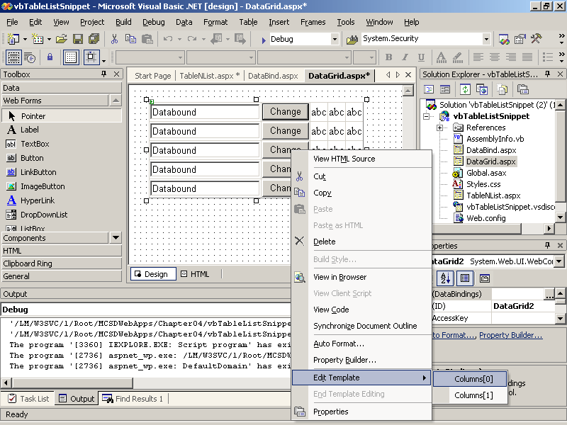
Figure 4-9. The bound controls
Performing Commands
The Button, LinkButton, and ImageButton server controls all trigger postback events to perform commands. A postback event begins a request from the browser, causing the server to process the page’s events. The Click event procedure for a button control is processed after any validation or cached events on a page.
To see the order of page events, place a TextBox control, a ListBox control, and a Button control on a Web form and add the following code:
Visual Basic .NET
Private Sub Page_Load(ByVal sender As System.Object, _
ByVal e As System.EventArgs) Handles MyBase.Load
Response.Write("Page load.<br>")
' Add items to list box the first time the page loads.
If Not IsPostBack Then
ListBox1.Items.Add("This")
ListBox1.Items.Add("That")
ListBox1.Items.Add("The other")
End If
End Sub

Private Sub TextBox1_TextChanged(ByVal sender As System.Object, _
ByVal e As System.EventArgs) Handles TextBox1.TextChanged
Response.Write("Text changed.<br>")
End Sub

Private Sub ListBox1_SelectedIndexChanged(ByVal sender As System.Object, _
ByVal e As System.EventArgs) Handles ListBox1.SelectedIndexChanged
Response.Write("Item selected.<br>")
End Sub

Private Sub Button1_Click(ByVal sender As System.Object, _
ByVal e As System.EventArgs) Handles Button1.Click
Response.Write("Button clicked.<br>")
End Sub
Visual C#
private void Page_Load(object sender, System.EventArgs e)
{
Response.Write("Page load.<br>");
// Add items to list box the first time the page loads.
if (!IsPostBack)
{
ListBox1.Items.Add("This");
ListBox1.Items.Add("That");
ListBox1.Items.Add("The other");
}
}

private void TextBox1_TextChanged(object sender,
System.EventArgs e)
{
Response.Write("Text changed.<br>");
}

private void ListBox1_SelectedIndexChanged(object sender,
System.EventArgs e)
{
Response.Write("Item selected.<br>");
}
private void Button1_Click(object sender, System.EventArgs e)
{
Response.Write("Page load.<br>");
}
When you run the preceding code, the page displays the event order, as shown in Figure 4-10. The Click event procedure is the last control event processed on a page.
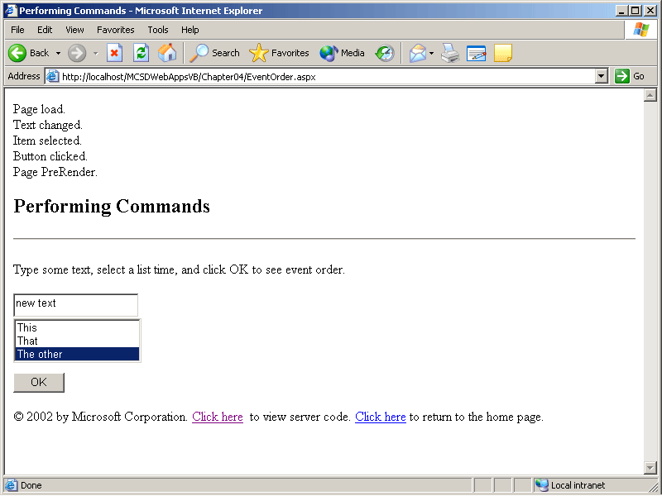
Figure 4-10. Event order
Using the Button and LinkButton controls’ Click event procedure is straightforward. The ImageButton control provides an additional capability. The Click event argument for the ImageButton control includes the xy-coordinates for where the user clicked on the control. The image response depends on where it was clicked, as shown in Figure 4-11. Images that respond to clicks in this way are called image maps.
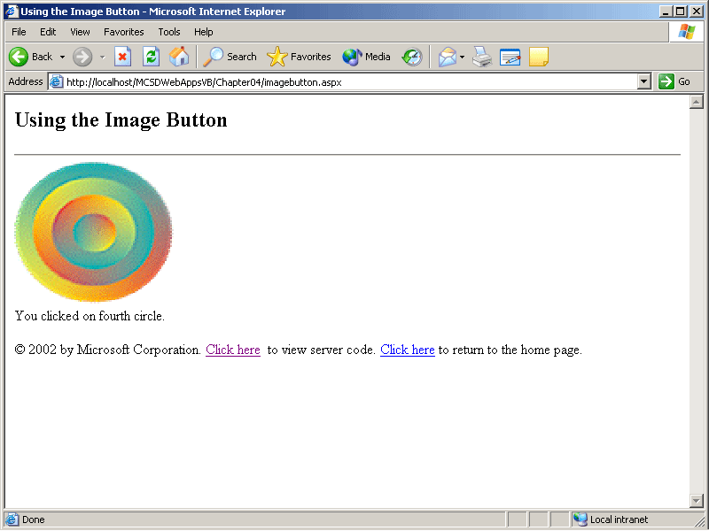
Figure 4-11. ImageButton control
The following code uses the ImageButton control’s e.X and e.Y arguments to calculate which circle was clicked in Figure 4-11:
Visual Basic .NET
Private Sub ImageButton1_Click(ByVal sender As System.Object, _
ByVal e As System.Web.UI.ImageClickEventArgs) Handles ImageButton1.Click
Dim xOffset, yOffset, X, Y, Radius As Single
Dim strMessage As String
' Calculate the radius of the click from X, Y.
xOffset = CSng(sender.width.value) / 2
yOffset = CSng(sender.height.value) / 2
X = System.Math.Abs(CSng(e.X) - xOffset)
Y = System.Math.Abs(CSng(e.Y) - yOffset)
Radius = System.Math.Sqrt((X ^ 2) + (Y ^ 2))
' Set the message to display.
Select Case CInt(Radius)
Case 0 To 21
strMessage = "on center circle."
Case 22 To 42
strMessage = "on second circle."
Case 43 To 64
strMessage = "on third circle."
Case 65 To 86
strMessage = "on fourth circle."
Case Else
strMessage = "outside of circle."
End Select
' Display the message.
Label1.Text = "You clicked " & strMessage
End Sub
Visual C#
private void ImageButton1_Click(System.Object sender,
System.Web.UI.ImageClickEventArgs e)
{
double xOffset, yOffset, X, Y, Radius;
string strMessage;
// Calculate the radius of the click from X, Y.
xOffset = Convert.ToDouble(ImageButton1.Width.Value) / 2;
yOffset = Convert.ToDouble(ImageButton1.Height.Value) / 2;
X = Math.Abs(Convert.ToDouble(e.X) - xOffset);
Y = Math.Abs(Convert.ToDouble(e.Y) - yOffset);
Radius = Math.Sqrt(Math.Pow(X, 2) + Math.Pow(Y, 2));
if (Radius < 22)
{
strMessage = "on center circle.";
}
else if ((Radius >= 22) && (Radius <= 42))
{
strMessage = "on second circle.";
}
else if ((Radius > 42) && (Radius <= 64))
{
strMessage = "on third circle.";
}
else if ((Radius > 64) && (Radius <= 86))
{
strMessage = "on fourth circle.";
}
else
{
strMessage = "outside of circle.";
}
// Display the message.
Label1.Text = "You clicked " + strMessage;
}
Getting and Setting Values
Use the RadioButton, RadioButtonList, CheckBox, or CheckBoxList controls to get Boolean value settings from the user. As with the ListBox and DropDownList controls, use the Collection Editor to add items to a RadioButtonList or a CheckBoxList control. Click the control’s Items property to display the Collection Editor for that control.
Use the Checked property to get the setting from a CheckBox or a RadioButton control. For example, the following code displays whether or not the CheckBox1 control is selected:
Visual Basic .NET
Private Sub Button1_Click(ByVal sender As System.Object, _
ByVal e As System.EventArgs) Handles Button1.Click
Response.Write("Checkbox1 is " & CheckBox1.Checked.ToString)
End Sub
Visual C#
private void Button1_Click(object sender, System.EventArgs e)
{
Response.Write("Checkbox1 is " + CheckBox1.Checked.ToString());
}
When you first draw a RadioButton control on a Web form, it doesn’t automatically interact with the other RadioButton controls on the form the way OptionButton controls do on a Windows form. To get the controls to interact, you need to set the GroupName property for each RadioButton. Figure 4-12 shows three RadioButton controls with the same GroupName. Because these RadioButton controls have the same GroupName, selecting one clears any other selected control.
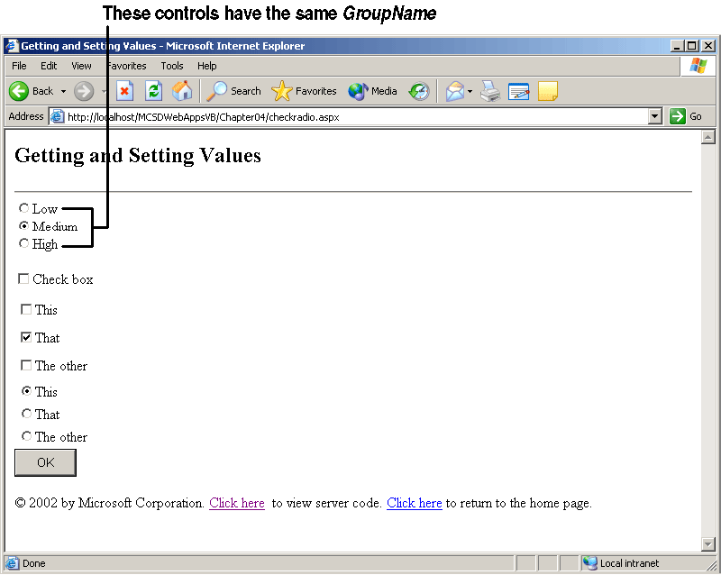
Figure 4-12. Grouped RadioButton controls
To get or set the values from a CheckBoxList or RadioButtonList control, use a For Each loop to check each control in the list. The controls contained in a CheckBoxList control are not CheckBox controls, as you might expect. Instead, the CheckBoxList and RadioButtonList controls contain ListControls. To determine the setting of a ListControl control, use the Selected property, as shown in the following code:
Visual Basic .NET
Private Sub Button1_Click(ByVal sender As System.Object, _
ByVal e As System.EventArgs) Handles Button1.Click
Dim lstItem As ListItem
For Each lstItem In RadioButtonList1.Items
If lstItem.Selected Then
Response.Write(lstItem.Text & " is selected.<br>")
End If
Next
End Sub
Visual C#
private void Button1_Click(object sender, System.EventArgs e)
{
foreach (ListItem lstItem in RadioButtonList1.Items)
{
if (lstItem.Selected)
Response.Write(lstItem.Text +
" is selected.<br>");
}
}
Displaying Graphics and Advertisements
There are many ways to display graphics on a Web form:
- As a background
Use the Background property of the Web form to display an image on the entire page. Use the BackImageUrl property of the Panel control to display a background image in one region of a page, rather than over the entire page.
- As a foreground
Use the Image control to display images in the foreground.
- As a button
Use the ImageButton control to display images that respond to user events. See the section “Performing Commands,” earlier in this lesson, for an example of responding to click events on an image.
- As an ad
Use the AdRotator control to display images from a list of ads. Ads displayed in the AdRotator control contain hyperlinks to the advertiser’s Web site.
The Image control does not respond to user events, but it allows you to display graphics dynamically based on input from other controls. To display an image in an Image control at run time, use the ImageUrl property. For example, the following code displays a picture of Venice, Italy, when the user clicks a button:
Visual Basic .NET
Private Sub Button1_Click(ByVal sender As System.Object, _
ByVal e As System.EventArgs) Handles Button1.Click
Image1.ImageUrl = "gondola.jpg"
End Sub
Visual C#
private void Button1_Click(object sender, System.EventArgs e)
{
Image1.ImageUrl = "gondola.jpg";
}
A common use of graphics is for advertisements—most Internet ads are stored as .gif files. Visual Studio includes the AdRotator control to handle the tasks associated with displaying these types of ads. The AdRotator control uses an XML file to schedule the ads that are displayed. The XML file stores the URL of the advertisement’s image, the URL of the page to display if the user clicks the ad, the priority of the ad, and other properties of the ad. At run time, the AdRotator control selects one of the ads listed in its XML file and displays it on the page.
To use the AdRotator control, follow these steps:
- Draw an AdRotator control on a Web form.
- Add an XML file to the current project and open it.
- In the Properties window, select the TargetSchema property, and then select AdRotator Schedule File from the drop-down list of property settings. Visual Studio adds the following lines to the XML file:
- <Advertisements xmlns=
- "http://schemas.microsoft.com/AspNet/AdRotator-Schedule-File">

</Advertisements>
- Add <Ad> tags to the <Advertisements> section of the XML file for each ad you want to display.
- Save the XML file, and switch back to the Web form in Design view.
- Select the AdRotator control, and set the AdvertisementsFile property to the XML file you just created.
Now edit the XML file to display the desired information. For example, the following XML file displays two different ads:
<?xml version="1.0" encoding="utf-8" ?>
<Advertisements xmlns=
"http://schemas.microsoft.com/AspNet/AdRotator-Schedule-File">
<Ad>
<ImageUrl>../ads/sponsorad.gif</ImageUrl>
<NavigateUrl>/ads/sponsorad.htm</NavigateUrl>
<AlternateText>Click here to visit our sponsor.</AlternateText>
<Keyword></Keyword>
<Impressions>1</Impressions>
</Ad>
<Ad>
<ImageUrl>../ads/net.gif</ImageUrl>
<NavigateUrl>//www.gotdotnet.com</NavigateUrl>
<AlternateText> ASP.NET tutorials and more.</AlternateText>
<Keyword>ASP</Keyword>
<Keyword>.NET</Keyword>
<Impressions>5</Impressions>
</Ad>
</Advertisements>
The tags in the AdRotator XML schema are defined in Table 4-5.
Table 4-5. The AdRotator XML Schema
Tag | Meaning
<Ad> | Begins an ad.
<ImageUrl> | The address of the ad to display.
<NavigateUrl> | The address to navigate to if the user clicks the ad.
<AlternateText> | The text to display in a ToolTip if the user pauses the mouse over the ad. Also, if the ad at the ImageUrl address can’t be displayed, this text appears in its place.
<Keyword> | A category name to use for filtering the ads to display.
<Impressions> | A number representing the likelihood that an ad will be displayed. Ads with higher numbers are more likely to be displayed.
Grouping Controls
Place controls in a group when you want to manipulate a particular region of your Web form in code. For example, you might want to allow users to log on to a system from a region of a page and then hide or disable that region once they are logged on.
Use the Panel control to group controls on a Web form. Using the Panel control on a Web form is different from using the Panel control on a Windows form. For one thing, you can’t draw controls on a Panel control. You must first draw your controls on the Web form, and then drag them onto the Panel control. For another thing, the Web Forms Panel control uses flow layout rather than grid layout. This means that you can’t drag a control to an exact position on a panel.
NOTE
You don’t have to place RadioButton controls in a panel to get them to work together. Instead, you enter a name in their GroupName property. See the section “Getting and Setting Values,” earlier in this lesson, for more information.
To position controls on a Panel control, follow these steps:
- Draw the controls on the Web form.
- Drag the controls onto the Panel control in the order in which you want them displayed. Visual Studio will place each control immediately after the next in sequence.
- Use carriage returns and spaces to place the controls where you want them to appear.
Figure 4-13 shows a group of controls that allow you to log on to a Web site. After the user logs on, the panel is hidden and a welcome message is displayed.
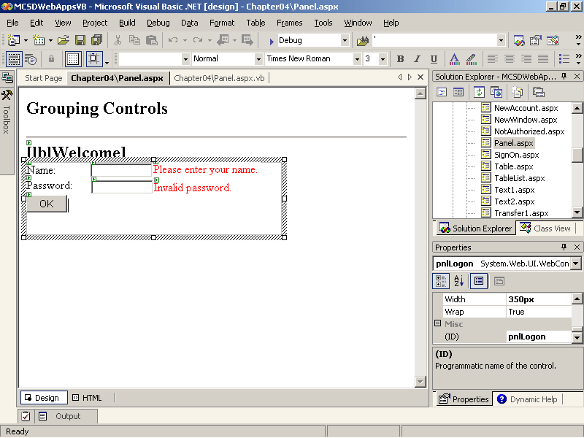
Figure 4-13. Positioning controls in a panel
The following code hides the panel after the user is logged on:
Visual Basic .NET
Private Sub butOK_Click(ByVal sender As System.Object, _
ByVal e As System.EventArgs) Handles butOK.Click
' If name/password match, hide logon panel and show message.
If txtName.Text = "Guest" And txtPassword.Text = "Wombat" Then
pnlLogon.Visible = False
lblWelcome.Text = "Welcome " & txtName.Text
Else
txtPassword.Text = ""
vldPassword.Validate()
End If
End Sub
Visual C#
private void butOK_Click(object sender, System.EventArgs e)
{
// If name/password match, hide the logon panel
// and show message.
if ((txtName.Text == "Guest") &&
(txtPassword.Text == "Wombat"))
{
pnlLogon.Visible = False;
lblWelcome.Text = "Welcome " + txtName.Text;

}
else
{
txtPassword.Text = "";
vldPassword.Validate();
}
}
Getting Dates
Use the Calendar control to get or display date information. The Calendar control provides properties to control the appearance of elements on the calendar, as shown in Figure 4-14.
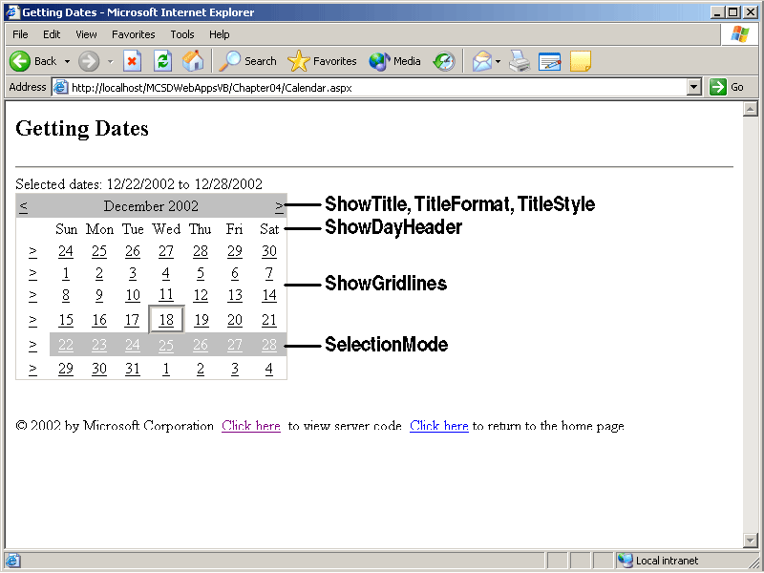
Figure 4-14. Calendar control properties
To get or set dates selected on the Calendar control, use the SelectionChanged event procedure and the SelectedDate or SelectedDates properties. SelectionChanged is a postback event, so the following code displays the selected date or dates as soon as the selection changes:
Visual Basic .NET
Private Sub Page_Load(ByVal sender As System.Object, _
ByVal e As System.EventArgs) Handles MyBase.Load
' Display current date in the label to start.
lblDate.Text = "Current date: " & Date.Now.Date
End Sub

Private Sub calSource_SelectionChanged(ByVal sender As System.Object, _
ByVal e As System.EventArgs) Handles calSource.SelectionChanged
If calSource.SelectedDates.Count = 1 Then
' If one date is selected, display it in a label.
lblDate.Text = "Selected date: " & calSource.SelectedDate
Else
' If multiple dates are selected, display them.
lblDate.Text = "Selected dates: " & calSource.SelectedDates(0) & _
" to " & _
calSource.SelectedDates(calSource.SelectedDates.Count - 1)
End If
End Sub
Visual C#
private void Page_Load(object sender, System.EventArgs e)
{
// Display the current date.
lblDate.Text = "Current date: " +
calSource.TodaysDate;
}

private void calSource_SelectionChanged(object sender,
System.EventArgs e)
{
// Display the current date.
lblDate.Text = "Current date: " +
calSource.TodaysDate;
if (calSource.SelectedDates.Count == 1)
// If one date is selected, display it.
lblDate.Text = "Selected date: " +
calSource.SelectedDate;
else
// If multiple dates are selected, display them.
lblDate.Text = "Selected dates: " +
calSource.SelectedDates[0] + " to " +
calSource.SelectedDates
[calSource.SelectedDates.Count - 1];
}
Getting Files from the Client
Use the File Field HTML control to upload files from the client to the server. The File Field HTML control is actually a Text Field HTML control and a Submit Button HTML control bound together. Clicking the Browse button runs a built-in script that displays the Windows Choose File dialog box on the client’s computer, as shown in Figure 4-15.
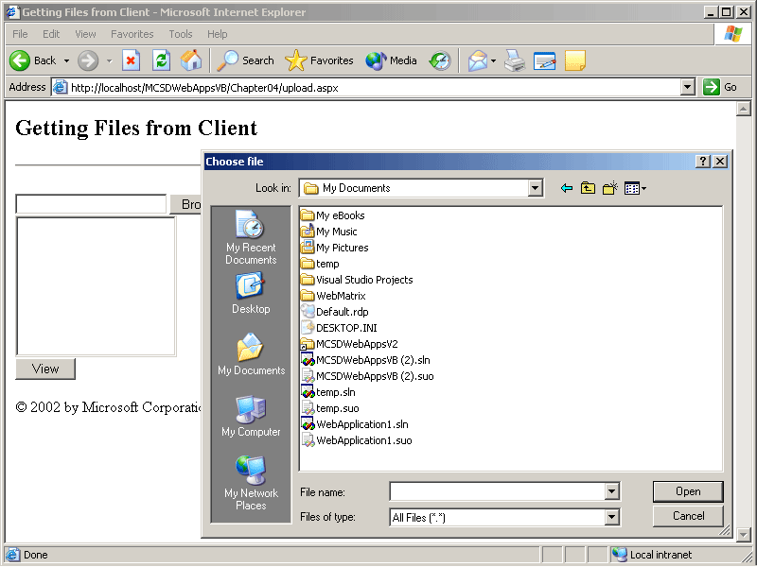
Figure 4-15. The Windows Choose File dialog box
To receive the selected client file on the server, follow these steps:
- Draw a File Field HTML control on a Web form.
- Right-click the control, and select Run As Server Control from the shortcut menu.
- Right-click the Web form, and select View HTML Source. Visual Studio displays the HTML code for the Web form.
- Add an enctype attribute to the <form> tag in the Web form’s HTML. The enctype attribute sets the MIME type of the form, and uploading a file requires both a MIME type of multipart/form-data and a form method of post, as shown here in boldface:
<form action="webform1.aspx" method="post" enctype="multipart/form-data" runat="server" ID="Form1">
- Right-click the Web form, and select View Design from the shortcut menu. Visual Studio displays the Web Forms Designer.
- Add a Button control and a Click event procedure to the Web form to get and save the selected file. For example, the following event procedure saves the file to the server:
Visual Basic .NET
Private Sub butUpload_Click(ByVal sender As System.Object, _
ByVal e As System.EventArgs) Handles butUpload.Click
Dim strFilename As String
Try
' Get the file name.
strFilename = filUpload.PostedFile.FileName
' Exit if no file name was entered.
If strFilename = "" Then Return
' If file has zero length (did not exist on client)
If filUpload.PostedFile.ContentLength = 0 Then
' Display message.
lblMsg.Text = "File not found on client or contains no data."
' Exit.
Return
End If
' Get the base name for the file (exclude path).
strFilename = System.IO.Path.GetFileName(strFilename)
' Save uploaded file to server.
filUpload.PostedFile.SaveAs(Request.MapPath("./uploadfiles") & _
"\" & strFilename)
' Add file to list of server files.
lstServerFiles.Items.Add(strFilename)
' Select an item in the list.
lstServerFiles.SelectedIndex = 0
Catch ex As System.UnauthorizedAccessException
lblMsg.Text = "You must set the permissions on the server " & _
"to allow the ASPNET user to write to the destination folder."
Catch ex As Exception
lblMsg.Text = "An unexpected error occurred: " & ex.Message
Finally
End Try
End Sub
Visual C#
private void butUpload_Click(object sender, System.EventArgs e)
{
string strFilename;
try
{
// Get the file name.
strFilename = filUpload.PostedFile.FileName;
// Exit if no file name was entered.
if (strFilename == "") return;
// if file is zero length, it is empty or doesn't exist.
if (filUpload.PostedFile.ContentLength == 0)
{
lblMsg.Text = "File was not found on client
or file contains no data.";
return;
}
// Get the base name for the file (exclude path).
strFilename = System.IO.Path.GetFileName(strFilename);
// Save uploaded file to server.
filUpload.PostedFile.SaveAs(Request.MapPath("./uploadfiles")
+ "\\" + strFilename);
// Add file to list of server files.
lstServerFiles.Items.Add(strFilename);
// Select an item in the list.
lstServerFiles.SelectedIndex = 0;
}
catch (System.UnauthorizedAccessException ex)
{
lblMsg.Text = "You must set the permissions on the server
to allow the ASPNET user to write to the destination folder.";
}
catch (Exception ex)
{
lblMsg.Text = "An unexpected error occurred: "
+ ex.Message;
}
finally {}
}
The PostedFile method of the File Field HTML control represents the file being uploaded. You can use the FileName property and SaveAs method of the returned object to save the file on the server, as shown in the preceding code. The following code shows one way to retrieve the file from the server. In this case, the file is displayed in the browser.
Visual Basic .NET
Private Sub butView_Click(ByVal sender As System.Object, _
ByVal e As System.EventArgs) Handles butView.Click
Dim strFilename As String
' Get selected file name.
strFilename = lstServerFiles.SelectedItem.ToString
' Display as Web page.
Response.Redirect("./uploadfiles/" & "/" & strFilename)
End Sub
Visual C#
private void butView_Click(object sender, System.EventArgs e)
{
// Get selected file name.
string strFilename =
lstServerFiles.SelectedItem.ToString();
// Display as web page.
Request.MapPath(".\\uploadfiles\\") + strFilename);
}
Lesson 2: Validating Data
One of the most important steps in getting data entries from a user is ensuring that the data is valid. Validity is determined by a number of criteria: Did the user enter anything? Is the entry the appropriate kind of data (a telephone number, for example)? Is the data within a required range?
ASP.NET provides validation controls to help you check Web form data entries against these and other criteria before the data items are accepted. This lesson teaches you how to use the validation controls to catch invalid data and direct the user to fix the problems that occur.
After this lesson, you will be able to
- Explain how ASP.NET checks validity, including why it checks validity both on the client side and on the server side
- Validate data entries in a TextBox control using one or more criteria
- Display error messages to help users correct data validation problems on a Web form
- Cancel validation to allow the user to exit from a Web form that has validation errors
- Create custom validation criteria to be evaluated on the server or client, or both
Estimated lesson time: 40 minutes
Using Validation
The validation controls check the validity of data entered in associated server controls on the client before the page is posted back to the server. This is an important improvement to previous validation schemes—most validity problems can be caught and corrected by the user without a round-trip to the server.
Client-side validation is provided by a JScript library named WebUIValidation.js, which is downloaded separately to the client. Although JScript is widely supported, the Document Object Model (DOM) that the library relies on is available only in Microsoft Internet Explorer version 4.0 and later. Therefore, validation controls also automatically provide server-side validation. Server-side validation is always performed, whether or not client-side validation has occurred. This double-checking ensures that custom validations are performed correctly and that client-side validation has not been circumvented.
The validation controls check the value of the server control specified in their ControlToValidate property. Table 4-6 describes the six validation controls.
Table 4-6. ASP.NET Validation Controls
Validation control | Use to
RequiredFieldValidator | Check whether a control contains data
CompareValidator | Check whether an entered item matches an entry in another control
RangeValidator | Check whether an entered item is between two values
RegularExpressionValidator | Check whether an entered item matches a specified format
CustomValidator | Check the validity of an entered item using a client-side script or a server-side code, or both
ValidationSummary | Display validation errors in a central location or display a general validation error description
To use the validation controls, follow these steps:
- Draw a validation control on a Web form and set its ControlToValidate property to the control you want to validate. If you’re using the CompareValidator control, you also need to specify the ControlToCompare property.
- Set the validation control’s ErrorMessage property to the error message you want displayed if the control’s data is not valid.
- Set the validation control’s Text property if you want the validation control to display a message other than the message in the ErrorMessage property when an error occurs. Setting the Text property lets you briefly indicate where the error occurred on the form and display the longer ErrorMessage property in a ValidationSummary control.
- Draw a ValidationSummary control on the Web form to display the error messages from the validation controls in one place.
- Provide a control that triggers a postback event. Although validation occurs on the client side, validation doesn’t start until a postback is requested.
Figure 4-16 shows simple validation being performed on a Web form.
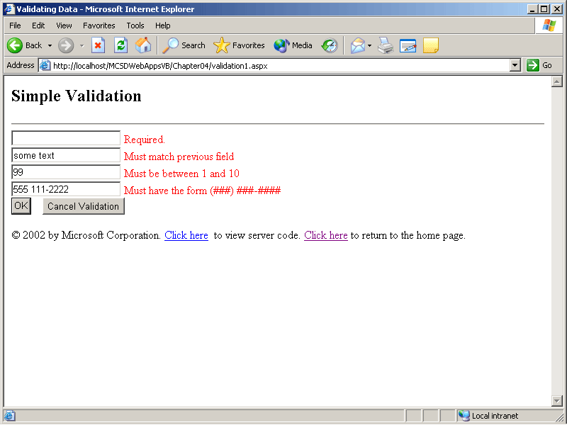
Figure 4-16. Validation on a Web form
Figure 4-17 shows validation using a ValidationSummary control. Notice that the individual validators display their Text properties, whereas the longer ErrorMessage property is displayed in the ValidationSummary control.
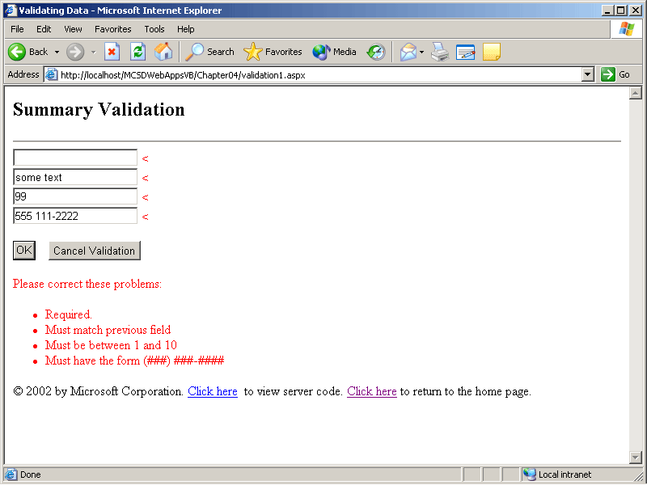
Figure 4-17. Using the ValidationSummary control
To display validation errors as a dialog box, set the ValidationSummary control’s ShowMessage property to True. You can see the result in Figure 4-18.
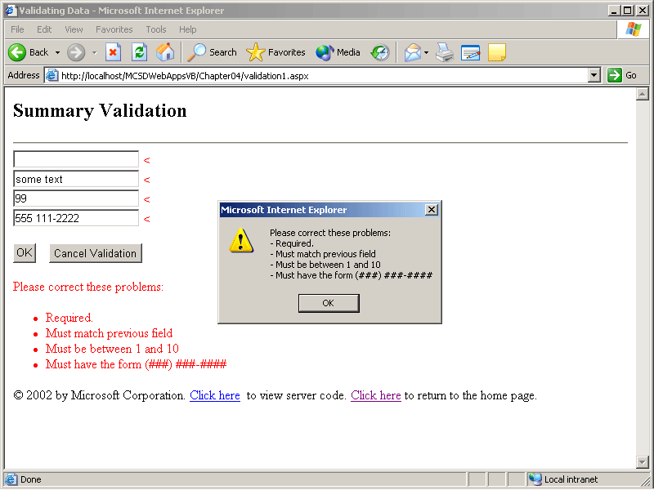
Figure 4-18. The validation errors dialog box
TIP
Use the RequiredFieldValidator control’s InitialValue property to ignore instructions included in the control to validate. For example, if the control to validate is a DropDownList that includes an item in with the text Select an item, enter Select an item in the RequiredFieldValidator control’s InitialValue property to make that selection invalid.
Combining Validations
A server control can have multiple validators. For instance, a TextBox control for a telephone number might be both a required field and a regular expression, so the TextBox would be checked by two validation controls, as shown in Figure 4-19.
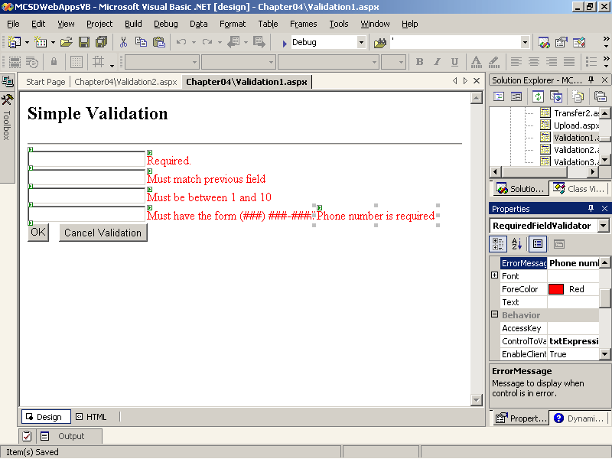
Figure 4-19. Multiple validators
To write meaningful error messages when more than one validation control checks a single control, you need to understand the ASP.NET validation rules. These rules might not make obvious sense, but they make it possible to write error messages that address specific problems.
For example, all validation controls except the RequireFieldValidator control are considered valid if they are blank. This makes it possible to provide one error message if the control is blank, using the RequiredFieldValidator control, and a different error message if the control is out of range or not in the appropriate format, as shown in the telephone number example in Figure 4-19.
The rules listed in Table 4-7 apply to data conversion for the CompareValidator control.
Table 4-7. CompareValidator Validation Rules
If the value from the control | The result is
Specified in the ControlToValidate property can’t be converted to the appropriate data type | Invalid
Specified in the ControlToCompare property can’t be converted to the appropriate data type | Valid
In the second case in Table 4-7, you should provide a separate validation control for the control specified in the ControlToCompare property to make sure value entered in the control is the appropriate data type.
Canceling Validation
Because validation occurs before the server processes the page, a user can become trapped by validation unless you provide a way to cancel validation without posting back.
To let the user cancel validation, provide a Submit HTML control that sets the Page_ValidationActive attribute, as shown in boldface in the following HTML code:
<INPUT id="butCancel" onclick="Page_ValidationActive=false;" style="Z INDEX :
114; LEFT: 386px; WIDTH: 62px; POSITION: absolute; TOP: 130px; HEIGHT: 30px"
type="submit" value="Cancel">
The preceding button definition cancels validation and posts the page back to the server. You can determine whether the user has cancelled the operation by checking the Page object’s IsValid property in the Page_Load event procedure. You have to revalidate the page because canceling validation sets IsValid to True. The following code shows how to check whether the user cancelled validation:
Visual Basic .NET
Private Sub Page_Load(ByVal sender As System.Object, _
ByVal e As System.EventArgs) Handles MyBase.Load
' Validate in case user cancelled validation.
If Page.IsPostBack Then Page.Validate()
' Check if page is valid.
If Not Page.IsValid Then
' User cancelled operation, return home.
Response.Redirect("default.htm")
End If
End Sub
Visual C#
private void Page_Load(object sender, System.EventArgs e)
{
// Validate in case user cancelled validation.
if (Page.IsPostBack)
{
Page.Validate();
if (!Page.IsValid)
// User cancelled validation.
Response.Redirect("default.htm");
}
}
Customizing Validation
To perform complex types of validation not provided by the standard validation control, use a CustomValidator control and write code to perform the validation on the server side and (optionally) on the client side.
On the server side, place your validation code in the ServerValidate event procedure. The arguments to this procedure provide access to the control to validate. The following event procedure validates that an entered number is prime:
Visual Basic .NET
' Validate a prime number.
Private Sub CustomValidator1_ServerValidate _
(ByVal source As System.Object, ByVal args As _
System.Web.UI.WebControls.ServerValidateEventArgs) _
Handles CustomValidator1.ServerValidate
Try
Dim iPrime, iCount As Integer
' Get value from ControlToValidate (passed as args)
iPrime = Integer.Parse(args.Value)
For iCount = 2 To iPrime \ 2
' If number is evenly divisible, it's
' not prime, return False.
If iPrime Mod iCount = 0 Then
args.IsValid = False
Return
End If
Next
' Number is Prime, return True.
args.IsValid = True
Return
Catch ex As Exception
' If there was an error parsing, return False.
args.IsValid = False
Return
End Try
End Sub
Visual C#
private void vldtxtPrime_ServerValidate(object source,
System.Web.UI.WebControls.ServerValidateEventArgs args)
{
try
{
// Get value from ControlToValidate (passed as args).
int iPrime = Int32.Parse(args.Value);
for (int iCount = 2; iCount <= (iPrime / 2); iCount++)
{
// If number is evenly divisible, it's
// not prime,return False.
if((iPrime % iCount) == 0)
{
args.IsValid = false;
return;
}
// Number is prime, return True.
args.IsValid = true;
return;
}
}
catch(Exception e)
{
// If there was an error parsing, return False.
args.IsValid = false;
return;
}
}
To provide client-side validation, specify a validation script in the CustomValidator control’s ClientValidationFunction property. Client-side validation is optional, and if you provide it, you should maintain similar validation code in both places. The following script provides a client-side version of the prime number validation performed on the server:
VBScript
<script language="vbscript">
Sub ClientValidate(source, arguments)
For iCount = 2 To arguments.Value \ 2
' If number is evenly divisible, it's
' not prime, return False.
If arguments.Value Mod iCount = 0 Then
arguments.IsValid = False
Exit Sub
End If
Next
arguments.IsValid = True
End Sub
</script>
JScript
<script language="jscript">
function ClientValidate(source, arguments)
{
for (var iCount = 2; iCount <= arguments.Value / 2; iCount++)
{
// If number is evenly divisible,
// it's not prime. Return false.
if ((arguments.Value % iCount) == 0)
{
arguments.IsValid = false;
return false;
}
}
// Number is prime, return True.
arguments.IsValid = true;
return true;
}
</script>
Lesson 3: Navigating Between Forms
Linking information is the essence of the Web. In a Web Forms application, hyperlinks and the navigation methods are what link multiple Web forms together into a cohesive application. ASP.NET provides several ways to navigate between pages in your application, and each of these techniques yields different effects in terms of how the page is displayed and how data is exchanged between pages.
In this lesson, you’ll learn how to use each of the different navigation techniques in code and in HTML.
After this lesson, you will be able to
- List different ways to navigate between pages in a Web forms application
- Choose the appropriate navigation technique based on your programming needs
- Retain form ViewState data across a request
- Process a second Web form without leaving the current Web form
- Display a page in a new browser window and control that window from server code
Estimated lesson time: 35 minutes
Ways to Navigate
ASP.NET provides five distinct ways to navigate between pages in your application, as shown in Table 4-8.
Table 4-8. Navigating Between Pages
Navigation method | Use to
Hyperlink control | Navigate to another page.
Response.Redirect method | Navigate to another page from code. This is equivalent to clicking a hyperlink.
Server.Transfer method | End the current Web form and begin executing a new Web form. This method works only when navigating to a Web Forms page (.aspx).
Server.Execute method | Begin executing a new Web form while still displaying the current Web form. The contents of both forms are combined. This method works only when navigating to a Web Forms page (.aspx).
Window.Open script method | Display a page in a new browser window on the client.
Using Hyperlinks and Redirection
Hyperlink server controls respond to user click events by displaying the page specified in the control’s NavigateURL property. The Hyperlink control does not expose any server-side user events; if you want to intercept a click event in code, use the LinkButton control or the ImageButton server control.
To navigate from a LinkButton or ImageButton control, use the Response object’s Redirect method, as shown here:
Visual Basic .NET
Private Sub LinkButton1_Click(ByVal sender As System.Object, _
ByVal e As System.EventArgs) Handles LinkButton1.Click
' Display next page.
Response.Redirect("NextPage.aspx")
End Sub
Visual C#
private void LinkButton1_Click(object sender, System.EventArgs e)
{
// Display next page.
Response.Redirect("NextPage.aspx");
}
Using the Transfer Method
Using the Transfer method is similar to executing a hyperlink or using the Redirect method, with one difference: Transfer can retain some information from the source page across requests. Setting the Transfer method’s preserveForm argument to True makes the form’s QueryString, ViewState, and event procedure information available in the destination form.
To be able to read one Web form’s ViewState from another, you must first set the EnableViewStateMac attribute in the Web form’s Page directive to False. By default, ASP.NET hashes ViewState information, and setting this attribute to False disables that hashing so that the information can be read on the subsequent Web form. The following line shows how to disable hashing so that a page’s ViewState can be used from another page:
Visual Basic .NET
<%@ Page language="vb" EnableViewStateMac="false"
Codebehind="RedirectNTransfer.aspx.vb"
Inherits="MCSDWebAppsVB.Transfer1" %>
Visual C#
<%@ Page language="c#" EnableViewStateMac="false"
Codebehind="RedirectNTransfer.aspx.cs" AutoEventWireup="false"
Inherits=" MCSDWebAppsVB.Transfer2" %>
The following event procedure for an ImageButton control shows how information can be passed between forms with the Transfer method:
Visual Basic .NET
' Transfer1.aspx
Private Sub imgTransfer_Click(ByVal sender As System.Object, _
ByVal e As System.Web.UI.ImageClickEventArgs) _
Handles imgTransfer.Click
' Transfer to another form, retaining ViewState.
Server.Transfer("Transfer2.aspx", True)
End Sub
Visual C#
// Transfer1.aspx
private void ImageButton1_Click(object sender,
System.Web.UI.ImageClickEventArgs e)
{
// Transfer to another form, retaining ViewState.
Server.Transfer("Transfer2.aspx", true);
}
WARNING
ASP.NET hashes ViewState information to prevent malicious users from manually changing the information passed back to the server and thus somehow corrupting data stored there. Disabling this hashing decreases the security of your Web application.
Use the Request object’s Form method to retrieve the ViewState information from the source Web form. The following code displays the values of two controls from the Transfer1.aspx Web form after the preceding Transfer method executes:
Visual Basic .NET
' Transfer2.aspx
Private Sub Page_Load(ByVal sender As System.Object, _
ByVal e As System.EventArgs) Handles MyBase.Load
Dim colForm As _
System.Collections.Specialized.NameValueCollection
' Get data from source Web form.
colForm = Request.Form
' Display the value from Webform1's TextBox.
Response.Write("TextBox1.Text: " & _
colForm.Item("TextBox1") & "<br>")
' Display the x, y coordinates of where the click occurr ed.
Response.Write("ImageButton X, Y coords: " & _
colForm.Item("imgTransfer.x") & ", " & _
colForm.Item("imgTransfer.y") & "<br>")
End Sub
Visual C#
// Transfer2.aspx
private void Page_Load(object sender, System.EventArgs e )
{
System.Collections.Specialized.NameValueCollection c olForm;
// Get data from the source Web form.
colForm = Request.Form;
// Display the value from Webform1's TextBox.
Response.Write("TextBox1.Text: " + colForm["TextBox1"]
+ "<br>");
// Display the X, Y coordinated of where the click occurred.
Response.Write("ImageButton X, Y coords: " +
colForm["imgTransfer.x"] + ", " + colForm["imgTransfer.y"]
+ "<br>");
}
You can use the Server object’s Transfer method to link control values across requests, as shown in Figure 4-20.
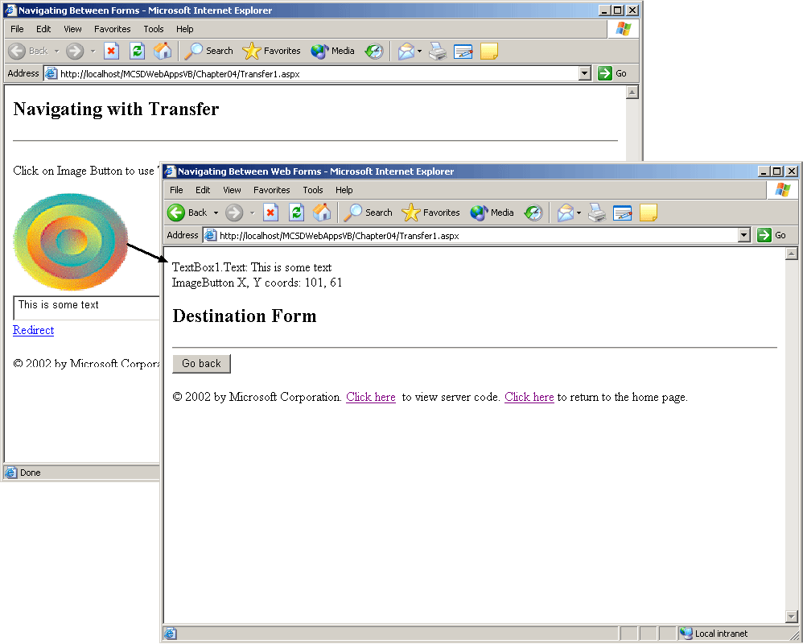
Figure 4-20. The Server object’s Transfer method
NOTE
The Server object’s Transfer and Execute methods work exclusively with Web forms. Trying to navigate to an HTML page using one of these methods results in a run-time error.
Using the Execute Method
Use the Server object’s Execute method to process a second Web form without leaving the first Web form. This technique lets you direct the results from a Web form to a region on the current page. As with the Transfer method, Execute requires that the Web form’s EnableViewStateMac attribute be set to False to disable ViewState hashing.
For example, the following code executes the Table.aspx Web form and displays it in a Literal control on the current page:
Visual Basic .NET
Private Sub butExecute_Click(ByVal sender As System.Object, _
ByVal e As System.EventArgs) Handles butExecute.Click
Dim swrTarget As New System.IO.StringWriter()
' Execute a Web form, store the results.
Server.Execute("Table.aspx", swrTarget)
' Display the result in a Literal control.
litTable.Text = "<h2>Table Results</h2>" & swrTarget.ToString
End Sub
Visual C#
private void butExecute_Click(object sender, System.EventArg s e)
{
System.IO.StringWriter swrTarget = new System.IO.StringWriter();
// Execute a Web form, store the results.
Server.Execute("Table.aspx", swrTarget);
// Display the result in a literal control.
litTarget.Text = "<h2>Table Results</h2>" + swrTarget.ToString();
}
The Execute method’s second argument is optional. If you omit it, the result is written to the current page. The result is additive—the content of both pages is displayed at the same time and server controls on both pages can respond to user events, as shown in Figure 4-21.
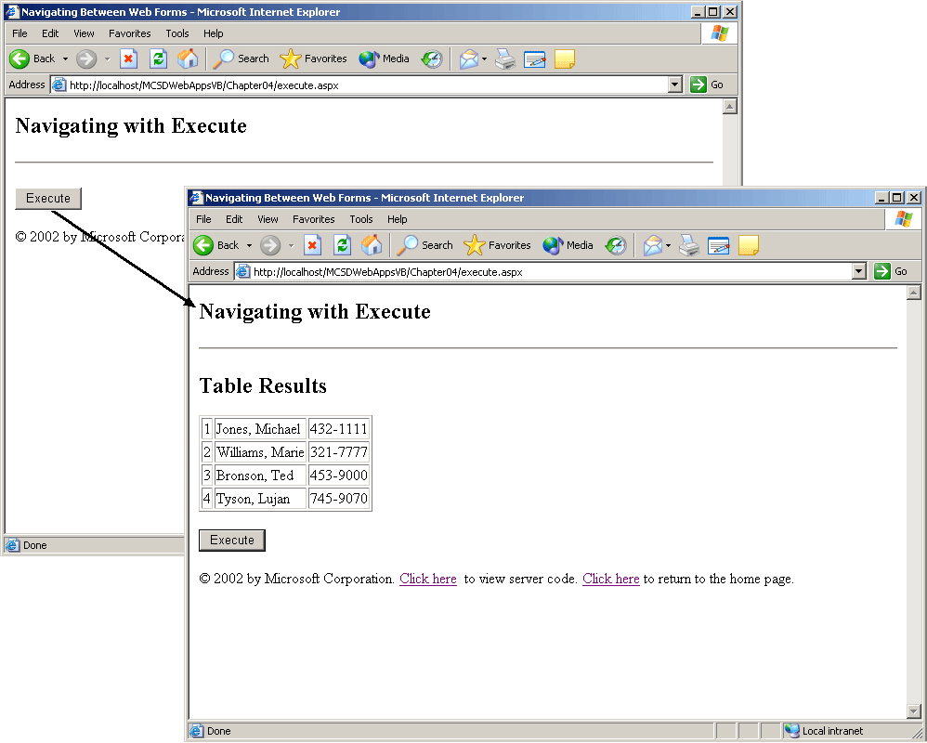
Figure 4-21. The Server object’s Execute method
When you combine Web forms using the Execute method, be aware that any postback events occurring on the second Web form will clear the first Web form. For this reason, combining Web forms is mainly useful when the second Web form does not contain controls that trigger postback events.
Displaying a Page in a New Browser Window
To start a new instance of the browser, use the client-side Window object’s Open method. You can do this only as part of a client script because the new window is created on the client. However, there are ways to control the content and appearance of the new browser window from the server.
In its simplest form, the Window.Open method takes the form shown in boldface for the following Button HTML control definition:
<INPUT style="Z-
INDEX: 102; LEFT: 55px; WIDTH: 81px; POSITION: absolute; TOP: 156px; H EIGHT
: 24px" onclick="window.open('transfer2.aspx')" type="submit"
value="New Window">
To use a variable as the target URL, replace webform2.aspx with a data tag:
<INPUT style="Z-
INDEX: 102; LEFT: 55px; WIDTH: 81px; POSITION: absolute; TOP: 156px; H EIGHT
: 24px" onclick="window.open('<%# urlTarget %>')" type="submit"
value="New Window">
To update the target URL from server code, use a Public variable and data binding. The following Page_Load event procedure sets the target URL and updates it with data binding when the page loads:
Visual Basic .NET
Public urlTarget As String
Private Sub Page_Load(ByVal sender As System.Object, _
ByVal e As System.EventArgs) Handles MyBase.Load
urlTarget = "transfer2.aspx"
Page.DataBind()
End Sub
Visual C#
public string urlTarget;
private void Page_Load(object sender, System.EventArgs e)
{
urlTarget = "transfer2.aspx";
Page.DataBind();
}
Because the Window.Open method takes many different arguments to control the various aspects of the new browser window, you might want to create a class to handle all the various settings. Classes allow you to encapsulate all the possible settings so that they can be used in an object-oriented manner. The following Page_Load event procedure and class definition demonstrate how to control the size, location, and URL of the new window from server-side code using a class named BrowserWindow:
Visual Basic .NET
Public urlTarget As New BrowserWindow()

Private Sub Page_Load(ByVal sender As System.Object, _
ByVal e As System.EventArgs) Handles MyBase.Load
With urlTarget
' Set URL for new window
.URL = "execute.htm"
.Top = 100
.Left = 100
.Width = 400
.Height = 400
End With
' Update HTML Button.
Page.DataBind()
End Sub

' Class to control new browser windows created in scripts.
' Default settings shown here are the same as browser defaul ts.
Public Class BrowserWindow
' String settings: default is blank.
Public URL As String = "about:blank"
' Integer settings: 0 invokes default.
Public Height As Integer = 0
Public Width As Integer = 0
Public Top As Integer = 0
Public Left As Integer = 0
' Boolean-like settings: 0 is "no" 1, is "yes"
Public ChannelMode As Integer = 0
Public Directories As Integer = 1
Public FullScreen As Integer = 0
Public Location As Integer = 1
Public Resizable As Integer = 1
Public ScrollBars As Integer = 1
Public Status As Integer = 1
Public TitleBar As Integer = 1
Public ToolBar As Integer = 1
Public MenuBar As Integer = 1
End Class
Visual C#
public BrowserWindow urlTarget = new BrowserWindow();

private void Page_Load(object sender, System.EventArgs e)
{
urlTarget.URL = "Execute.aspx";
urlTarget.Top = 100;
urlTarget.Left = 100;
urlTarget.Width = 400;
urlTarget.Height = 400;
// Update HTML Button.
Page.DataBind();
}

// Class to control new browser window create in scripts.
// Default settings shown here are the same as browser default s.
public class BrowserWindow
{
// String settings: default is blank.
public string URL = "about:blank";
// Integer settings: 0 invoked default.
public int Height = 0;
public int Width = 0;
public int Top = 0;
public int Left = 0;
// Boolean-like settings: 0 is "no", 1 is "yes".
public int ChannelMode = 0;
public int Directories = 1;
public int FullScreen = 0;
public int Location = 1;
public int Resizable = 1;
public int ScrollBars = 1;
public int Status = 1;
public int TitleBar = 1;
public int ToolBar = 1;
public int MenuBar = 1;
}
The HTML code for a button that uses these settings would look like the following example. (The server-supplied variable is shown in boldface.)
<INPUT style="Z-
INDEX: 103; LEFT: 25px; WIDTH: 126px; POSITION: absolute; TOP: 60px; H
EIGHT: 33px" type="button" value="Show New Window"
onclick="window.open('<%# urlTarget.URL %>', null,
'height=<%# urlTarget. Height %>,
width=<%# urlTarget.Width %>,
top=<%# urlTarget.Top %>,
left=<%# urlTarget.Left %>,
channelmode=<%# urlTarget.ChannelMode %>,
directories=<%# urlTarget.Directories %>,
fullscreen=<%# urlTarget.FullScreen %>,
location=<%# urlTarget.Location %>,
menubar=<%# urlTarget.MenuBar %>,
resizable=<%# urlTarg et.Resizable %>,
scrollbars=<%# urlTarget.ScrollBars %>,
status=<%# urlTarget.Status %>,
titlebar=<%# urlTarget.TitleBar %>,
toolbar=<%# urlTarget.ToolBar %>')">
Summary
- Server controls provide properties, methods, and events that can be used in server code.
- HTML controls provide attributes and events that can be used in scripts that run on the client. To access properties of an HTML control in server code, add a runat=server attribute to the control’s HTML definition.
- ASP.NET performs control validation on the client side immediately before posting the Web form back to the server. Once client-side validation succeeds, the Web form is validated again on the server side before the Page_Load event occurs. This ensures that the Web form has not been modified on the client to bypass validation, and it also guarantees that validation will work with a wide variety of browsers.
- Use multiple validation controls to check multiple conditions on a single data field. For example, a TextBox control that requires a telephone number should be validated by both a RequiredFieldValidator and a RegularExpressionValidator control.
- To navigate between pages in a Web forms application, use one of the following techniques. (The two Server object methods work only with Web forms.)
  - Hyperlinks
  - The Response.Redirect method
  - The Server.Transfer method
  - The Server.Execute method
  - Client script procedures
- To perform an action in the client browser, you must use a client script. For example, to open a page in a new window, you would use a Button HTML control with an onclick="window.open()" attribute. This is because client scripts are the only executable code in a Web forms application that runs on the client.
Lab: Building a Web-Based Text Editor
In this lab, you will create a multipage Web forms application that allows users to create and edit text files stored on a server. The application uses the user’s sign-on name to determine where files are stored. It does not do rigorous password checking—in fact, the password is always Guest. Password authentication is covered in Chapter 8, “Maintaining Security.”
Estimated lesson time: 45 minutes
IMPORTANT
To create and delete files, the ASPNET user account must have write and modify privileges in the application’s root folder. By default, the ASPNET user account has only read and execute privileges. See Chapter 9, “Building and Deploying Web Applications,” for information about how to assign security privileges in the application folder.
Exercise 1: Create the Sign-On Form

In this exercise, you’ll create the Web form that allows users to sign on to the text editor. The Web form created here uses validation, flow layout, navigation to other pages, and the System.IO namespace for directory services. When you have finished creating the Web form, it will appear as shown in Figure 4-22.
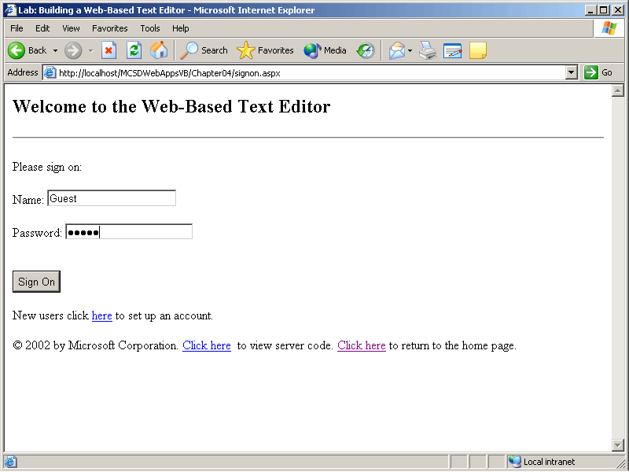
Figure 4-22. The SignOn.aspx Web form
To start the application and create the SignOn Web form
- Open a new ASP.NET Web application project. In the New Project dialog box, enter the name WebTextEditor.
- In the Properties window, change the name of the Webform1.aspx file to SignOn.aspx.
- In the Properties window, select the DOCUMENT object and set the pageLayout property to FlowLayout.
After you’ve set pageLayout to FlowLayout, you can add controls to the page by double-clicking the controls in the Toolbox. If you create the controls in the order they appear on the page, this process goes quickly. The following table shows the controls you should create in the order in which you create them, along with their property settings.
Control | Property | Value
Literal | ID | litNoAccount
TextBox | ID | txtName
RequiredFieldValidator | ID | vldtxtName
 | ControlToValidate | txtName
 | ErrorMessage | Please enter a name.
TextBox | ID | txtPassword
RequiredFieldValidator | ID | vldtxtPassword
 | ControlToValidate | txtPassword
 | ErrorMessage | Please enter the password.
RangeValidator | ID | vldtxtPasswordGuest
 | ControlToValidate | txtPassword
 | ErrorMessage | The password is “Guest”.
 | MinimumValue | Guest
 | MaximumValue | Guest
Button | ID | butSignOn
 | Text | Sign On
After you create the controls and set their properties, switch to HTML view, and edit the HTML elements directly.
To edit the Web form in HTML mode
- Right-click the Web form, and select View HTML Source from the shortcut menu.
- Edit the Web form by adding the following text and HTML tags shown in boldface:
- <form id="Form1" method="post" runat="server">
- <h2>
- Welcome to the Web-Based Text Editor
- </h2><asp:Literal id="litNoAccount" runat="server"></asp:Literal>
- <p>
- Please sign on:
- </p>
- Name:<asp:TextBox id="txtName" runat="server" Width="165px"></asp:TextBox>
- <asp:RequiredFieldValidator id="vldtxtName" runat="server" ErrorMessage="Please enter a name."
- ControlToValidate="txtName"></asp:RequiredFieldValidator>
- <br>
- <br>
- Password:<asp:TextBox id="txtPassword" runat="server" Width="163px" Height="21p x" TextMode="Password"></asp:TextBox>
- <asp:RequiredFieldValidator id="vldtxtPassword" runat="server" ErrorMessage="Please enter a password."
- ControlToValidate="txtPassword"></asp:RequiredFieldValidator>
- <br>
- <asp:RangeValidator id="vldtxtPasswordGuest" runat="server" ControlToValidate="txtPassword" ErrorMessage='The password is "Guest".'
- MaximumValue="Guest" MinimumValue="Guest"></asp:RangeValidator>
- <br>
- <br><asp:Button id="butSignOn" runat="server" Text="Sign On" Width="61px" Height="28px"></asp:Button>
- <p>
- New users click <a href="NewAccount.aspx">here</a> to set up an account.
</p></form>
- To view the results of the changes, right-click the Web form, and select View Design from the shortcut menu.
When you have finished editing the Web form, switch to Design view and double-click Sign On to display the Code window. Place the following Imports or using statement before the Web form’s class definition:
Visual Basic .NET
Imports System.IO
Visual C#
using System.IO;
Add the following code to the butClick event procedure:
Visual Basic .NET
Private Sub butSignOn_Click(ByVal sender As System.Object, _
ByVal e As System.EventArgs) Handles butSignOn.Click
Dim strPath As String
'If the user exists, there is a directory of the same name.
strPath = Server.MapPath(Request.ApplicationPath) & "\" & txtName. Text
If Directory.Exists(strPath) Then
' Set session variables.
Session("Path") = strPath
Server.Transfer("FileManager.aspx")
Else
' Otherwise, report that user wasn't found.
litNoAccount.Text = ("<p>The name " & txtName.Text & _
" wasn't found." & _
"Check the name, or click <A href='NewAccount.aspx'>here</ A>" & _
" if you are a new user.</p>")
End If
End Sub
Visual C#
private void butSignOn_Click(object sender, System.EventArgs e)
{
string strPath;
// If the user exists, there is a directory of the same name.
strPath = Server.MapPath(Request.ApplicationPath) + "\\"
+ txtName.Text;
if(Directory.Exists(strPath))
{
// Set session variables.
Session["Path"] = strPath;
Server.Transfer("FileManager.aspx");
}
else
// Otherwise, report that user wasn't found.
litNoAccount.Text = "<p>The name " + txtName.Text +
" wasn't found. Check the name, or click " +
"<A href='NewAccount.aspx'>here</A> if you " +
"are a new user.</p>";
}
Exercise 2: Create the NewAccount Form
In this exercise, you’ll create the Web form that creates an account for new users. In this application, an account consists of a directory in the application’s root that bears the user’s name. Again, there is no security provided in this exercise; security is covered in Chapter 8, “Maintaining Security.”
The Web form created here uses validation, flow layout, navigation, HTML controls, and the System.IO namespace for directory services. The form uses the username to create a directory for the user’s files in the application’s server root. When you have finished creating the Web form, it will appear as shown in Figure 4-23.
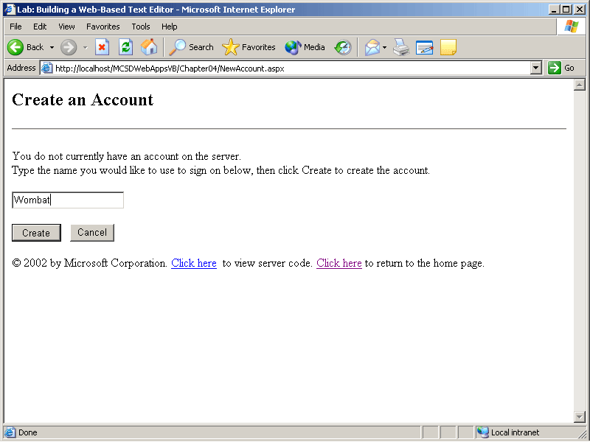
Figure 4-23. The NewAccount.aspx Web form
To create the NewAccount Web form
- Create a new Web form named NewAccount.aspx.
- In the Properties window, select the DOCUMENT object and set its pageLayout property to FlowLayout.
- Add controls and set their properties as shown in the following table:
Control | Property | Value
Literal | ID | litNameExists
TextBox | ID | txtName
RequiredFieldValidator | ID | vldtxtName
 | ControlToValidate | txtName
 | ErrorMessage | Please enter a name.
Button | ID | butCreate
 | Text | Create
Button HTML control | id | butCancel
 | value | Cancel
- Switch the Web form to HTML view, and add the following text and HTML tags shown in boldface:
- <form id="Form1" method="post" runat="server">
- <h2>
- Create an Account
- </h2><asp:Literal id="litNameExists" runat="server"></asp:Literal>
- <p>
- You do not currently have an account on the server.
- <br>
- Type the name you would like to use to sign on below, then click Create to
- create the account.
- </p><asp:TextBox id="txtName" runat="server" Width="153px"
- Height="24px"></asp:TextBox>
- <asp:RequiredFieldValidator id="vldtxtName" runat="server" ErrorMessage="Please enter a name."
- ControlToValidate="txtName"></asp:RequiredFieldValidator>
- <p>
- </p><asp:Button id="butCreate" runat="server" Text="Create" Width="67" Height="24"></asp:Button>
- &nbsp;&nbsp; <INPUT type="button" onclick="history.back()" value="Cancel"></BUTTON>
</form>
The last edit in the preceding HTML code, onclick="history.back()", enables the user to cancel the operation without causing validation. Using an HTML control here is important because you don’t want server-side processing—you just want to go back to the SignOn Web form.
When you have finished editing the Web form, switch back to Design view and double-click Create to display the Code window. Place the following Imports or using statement before the Web form’s class definition:
Visual Basic .NET
Imports System.IO
Visual C#
using System.IO;
Add the following code to the butCreate_Click event procedure:
Visual Basic .NET
Private Sub butCreate_Click(ByVal sender As System.Object, _
ByVal e As System.EventArgs) Handles butCreate.Click
Dim strPath As String
'Check if directory exists.
strPath = Server.MapPath(Request.ApplicationPath) & "\" & txtName. Text
If Directory.Exists(strPath) Then
' Tell the user to choose another name.
litNameExists.Text = "<p>The name " & txtName.Text & _
" already exists. Please choose a different one.</p>"
Return
Else
Try
' Create the directory.
Directory.CreateDirectory(strPath)
' Set the session variable.
Session("Path") = strPath
' Go to file manager.
Server.Transfer("FileManager.aspx")
Catch ex As System.UnauthorizedAccessException
Server.Transfer("NotAuthorized.aspx")
End Try
End If
End Sub
Visual C#
private void butCreate_Click(object sender, System.EventArgs e)
{
string strPath;
//Check if directory exists.
strPath = Server.MapPath(Request.ApplicationPath) + "\\"
+ txtName.Text;
if (Directory.Exists(strPath))
{
// Tell the user to choose another name.
litNameExists.Text = "<p>The name " + txtName.Text +
" already exists. Please choose a different one.</p>";
return;
}
else
{
try
{
// Create the directory.
Directory.CreateDirectory(strPath);
// Set the session variable.
Session["Path"] = strPath;
// Go to file manager.
Server.Transfer("FileManager.aspx");
}
catch (System.UnauthorizedAccessException ex)
{
Server.Transfer("NotAuthorized.aspx");
}
}
}
Exercise 3: Create the File Manager Form
In this exercise, you’ll create the Web form that lets users create, open, and delete files in their accounts on the server. The Web form created here uses data binding, flow layout, navigation, QueryStrings, and the System.IO namespace for file access. When you have finished creating the Web form, it will appear as shown in Figure 4-24.
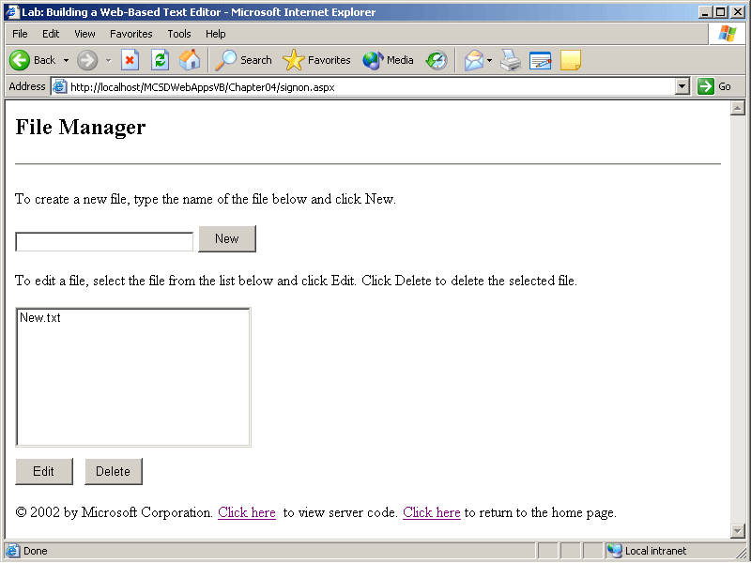
Figure 4-24. The FileManager.aspx Web form
To create the FileManager Web form
- Create a new Web form named FileManager.aspx.
- In the Properties window, select the DOCUMENT object and set its pageLayout property to FlowLayout.
- Add controls and set their properties as shown in the following table:
Control | Property | Value
Literal | ID | litNoFile
TextBox | ID | txtNewFile
Button | ID | butNew
 | Text | New
Literal | ID | litNoneSelected
ListBox | ID | lstFiles
 | DataSource | strFiles
Button | ID | butEdit
 | Text | Edit
Button | ID | butDelete
 | Text | Delete
- Switch the Web form to HTML view, and add the following text and HTML tags shown in boldface:
- <form id="Form1" method="post" runat="server">
- <h2>
- File Manager
- </h2>
- <p>
- To create a new file, type the name of the file below and click New.
- </p><asp:Literal id="litNoFile" runat="server"></asp:Literal>
- <asp:TextBox id="txtNewFile" runat="server" Width="191px"></asp:TextBox>
- <asp:Button id="butNew" runat="server" Width="62px" Height="29px" Text="New"></asp:Button>
- <p>
- To edit a file, select the file from the list below and click Edit. Click
- Delete to delete the selected file.
- </p><asp:Literal id="litNoneSelected" runat="server"></asp:Literal>
- <asp:listbox id="lstFiles" runat="server" Width="252px" Height="161px" DataSource="<%# strFiles %>"></asp:listbox>
- <br><asp:Button id="butEdit" runat="server" Width="62" Height="29" Text="Edit"></asp:Button>
- &nbsp;&nbsp;
- <asp:Button id="butDelete" runat="server" Width="62px" Height="29px" Text="Delete"></asp:Button>
</form>
- When you have finished editing the Web form, switch back to Design view and double-click New to display the Code window. Place the following Imports or using statement before the Web form’s class definition:
Visual Basic .NET
Imports System.IO
Visual C#
using System.IO;
- Add the following code to the form event procedures:
Visual Basic .NET
Public strPath As String, strFiles As String()
Private Sub Page_Load(ByVal sender As System.Object, _
ByVal e As System.EventArgs) Handles MyBase.Load
' Get path.
strPath = Session("Path")
' If this is not a post-back event.
If Not IsPostBack Then
Dim iCount As Integer
'Get list of files in the current directory.
strFiles = Directory.GetFiles(strPath)
' Get the short names for the files.
For iCount = 0 To UBound(strFiles)
strFiles(iCount) = Path.GetFileName(strFiles(iCount))
Next
End If
' Bind lstFiles to file array.
lstFiles.DataBind()
End Sub

Private Sub butNew_Click(ByVal sender As System.Object, _
ByVal e As System.EventArgs) Handles butNew.Click
' If there is a file name, then start the editor.
If txtNewFile.Text <> "" Then
Response.Redirect("EditFile.aspx?file=" & txtNewFile.Text)
Else
' Otherwise, display a message.
litNoFile.Text = "<p>You must enter the name of a file" & _
" to create.<p>"
End If
End Sub

Private Sub butEdit_Click(ByVal sender As System.Object, _
ByVal e As System.EventArgs) Handles butEdit.Click
' If there is a file name, then start the editor.
If Not IsNothing(lstFiles.SelectedItem) Then
Response.Redirect("EditFile.aspx?file=" & _
lstFiles.SelectedItem.ToString)
Else
' Otherwise, display a message.
litNoneSelected.Text = "<p>You must select a file.<p>"
End If
End Sub
Private Sub butDelete_Click(ByVal sender As System.Object, _
ByVal e As System.EventArgs) Handles butDelete.Click
' If there is a file name, then start the editor.
If Not IsNothing(lstFiles.SelectedItem) Then
Try
Dim filToDelete As File
filToDelete.Delete(strPath & "\" & _
lstFiles.SelectedItem.ToString)
lstFiles.Items.Remove(lstFiles.SelectedItem)
Catch ex As System.Security.SecurityException
Server.Transfer("NotAuthorized.aspx")
End Try
Else
' Otherwise, display a message.
litNoneSelected.Text = "<p>You must select a file.<p>"
End If
End Sub
Visual C#
string strPath;
public string[] strFiles;

private void Page_Load(object sender, System.EventArgs e)
{
// Get path.
strPath = Session["Path"].ToString();
// If this is not a post-back event.
if(!Page.IsPostBack)
{
// Get list of files in the current directory.
strFiles = Directory.GetFiles(strPath);
// Get the short names for the files.
for (int iCount = 0; iCount <= strFiles.GetUpperBound(0);
iCount++)
strFiles[iCount] =
Path.GetFileName(strFiles[iCount]);
}
// Bind lstFiles to file array.
lstFiles.DataBind();
}

private void butNew_Click(object sender, System.EventArgs e)
{
//If there is a file name, then start the editor.
if (!(txtNewFile.Text == ""))
Response.Redirect("EditFile.aspx?file=" +
txtNewFile.Text);
else
// Otherwise, display a message.
litNoFile.Text = "<p>You must enter the name of a file " +
" to create.<p>";
}

private void butEdit_Click(object sender, System.EventArgs e)
{
// If there is a file name, then start the editor.
if (lstFiles.SelectedItem != null)
Response.Redirect("EditFile.aspx?file=" +
lstFiles.SelectedItem.ToString());
else
// Otherwise, display a message.
litNoneSelected.Text = "<p>You must select a file.<p>";
}

private void butDelete_Click(object sender, System.EventArgs e)
{
// If there is a file name, then start the editor.
if (lstFiles.SelectedItem != null)
try
{
File.Delete(strPath + "\\" +
lstFiles.SelectedItem.ToString());
lstFiles.Items.Remove(lstFiles.SelectedItem);
}
catch(System.UnauthorizedAccessException ex)
{
Server.Transfer("NotAuthorized.aspx");
}
else
// Otherwise, display a message.
litNoneSelected.Text = "<p>You must select a file.<p>";
}
Exercise 4: Create the File Editor Form
In this exercise, you’ll create the Web form that edits files stored on the server in the user’s account. The Web form created here uses the same layout and programming techniques as the Web form example in Exercise 3. When you have finished creating the Web form, it will appear as shown in Figure 4-25.
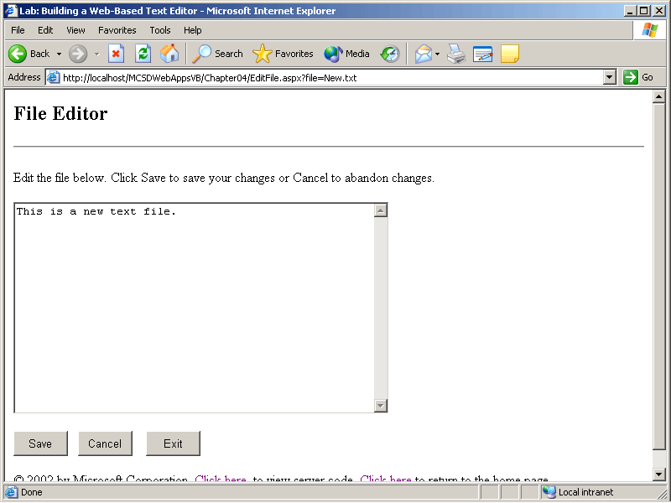
Figure 4-25. The EditFile.aspx Web form
To create the File Editor Web form
- Create a new Web form named EditFile.aspx.
- In the Properties window, select the DOCUMENT object and set its pageLayout property to FlowLayout.
- Add controls and set their properties as shown in the following table:
Control | Property | Value
TextBox | ID | txtEditFile
 | TextMode | Multiline
Button | ID | butSave
 | Text | Save
HTML Button | id | butCancel
 | value | Cancel
Button | ID | butExit
 | Text | Exit
- Switch the Web form to HTML view, and add the following text and HTML tags shown in boldface:
- <form id="Form1" method="post" runat="server">
- <h2>
- File Editor
- </h2>
- <p>
- Edit the file below. Click Save to save your changes or Cancel to abandon
- changes.
- </p><asp:TextBox id="txtEditFile" runat="server" Width="448px" Height="253px" TextMode="MultiLine"></asp:TextBox>
- <p>
- </p><asp:Button id="butSave" runat="server" Width="65" Height="30" Text="Save"></asp:Button>
- &nbsp;&nbsp; <INPUT id="butCancel" onclick="history.back()" type="button" value="Cancel" style="WIDTH: 65px; HEIGHT: 30px">
- &nbsp;&nbsp;<asp:Button id="butExit" runat="server" Width="65" Height="30" Text="Exit"></asp:Button>
</form>
- When you have finished editing the Web form, switch back to Design view and double-click New to display the Code window. Place the following Imports or using statement before the Web form’s class definition:
Visual Basic .NET
Imports System.IO
Visual C#
using System.IO;
- Add the following code to the form event procedures:
Visual Basic .NET
Dim strPath, strFile As String
Private Sub Page_Load(ByVal sender As System.Object, _
ByVal e As System.EventArgs) Handles MyBase.Load
' Get the path and file names.
strPath = Session("Path")
strFile = Request.QueryString("file")
' If this is not a post-back event.
If Not IsPostBack Then
Dim strmEditFile As StreamReader
Try
' Open the file.
strmEditFile = File.OpenText(strPath & "\" & _
strFile)
' Read its text.
txtEditFile.Text = strmEditFile.ReadToEnd.ToString
' Close the file.
strmEditFile.Close()
Catch ex As System.IO.FileNotFoundException
' If it doesn't exist, create it.
File.CreateText(strPath + "\\" + strFile).Close()
' Clear text box.
txtEditFile.Text = ""
Catch ex As System.UnauthorizedAccessException
Server.Transfer("NotAuthorized.aspx")
End Try
End If
End Sub

Private Sub butExit_Click(ByVal sender As System.Object, _
ByVal e As System.EventArgs) Handles butExit.Click
If ViewState("changed") Then
SaveFile()
End If
' Return to File Manager.
Server.Transfer("FileManager.aspx")
End Sub

Private Sub txtEditFile_TextChanged(ByVal sender As System.Object, _
ByVal e As System.EventArgs) Handles txtEditFile.TextChanged
' Set changed flag.
ViewState("changed") = True
End Sub

Private Sub butSave_Click(ByVal sender As System.Object, _
ByVal e As System.EventArgs) Handles butSave.Click
SaveFile()
End Sub

Private Sub SaveFile()
Dim strmEditWrite As StreamWriter
' Delete the file.
File.Delete(strPath & strFile)
' Create the file with new text.
strmEditWrite = File.CreateText(strPath & "\" & strFile)
strmEditWrite.Write(txtEditFile.Text)
strmEditWrite.Close()
' Reset changed flag.
ViewState("changed") = False
End Sub
Visual C#
string strPath;
string strFile;

private void Page_Load(object sender, System.EventArgs e)
{
// Get the path and file names.
strPath = Session["Path"].ToString();
strFile = Request.QueryString["file"];
// If this is not a post-back event.
if (! Page.IsPostBack)
{
StreamReader strmEditFile;
try
{
// Open the file.
strmEditFile = File.OpenText(strPath + "\\" +
strFile);
// Read its text.
txtEditFile.Text =
strmEditFile.ReadToEnd().ToString();
// Close the file.
strmEditFile.Close();
}
catch(FileNotFoundException ex)
{
// If it doesn't exist, create it.
File.CreateText(strPath + "\\" +
strFile).Close();
// Clear text box.
txtEditFile.Text = "";
}
catch(System.UnauthorizedAccessException ex)
{
Server.Transfer("NotAuthorized.aspx");
}
}
}

private void butExit_Click(object sender, System.EventArgs e)
{
if ((ViewState["Changed"] != null) &&
(ViewState["Changed"].ToString() == "true"))
SaveFile();
// Return to File Manager.
Server.Transfer("FileManager.aspx");
}

private void txtEditFile_TextChanged(object sender, System.EventArgs e)
{
// Set changed flag.
ViewState["Changed"] = "true";
}

private void butSave_Click(object sender, System.EventArgs e)
{
SaveFile();
}

void SaveFile()
{
StreamWriter strmEditWrite;
// Delete the file.
File.Delete(strPath + strFile);
// Create the file with new text.
strmEditWrite = File.CreateText(strPath + "\\" + strFile);
strmEditWrite.Write(txtEditFile.Text);
strmEditWrite.Close();
// Reset changed flag.
ViewState["Changed"] = "false";
}
Exercise 5: Create the Not Authorized Web Form
As mentioned at the beginning of this lab, you must authorize the ASPNET user account to create and delete files in the application’s root folder. If you don’t grant these permissions, all attempts to create, save, or delete files result in a System.UnauthorizedAccessException error.
The code in the preceding exercises handles this error by using Try…Catch/try…catch exception handling blocks. If the error occurs, the Web-Based Text Editor displays a Web form with instructions for how to fix the error, as shown in Figure 4-26.
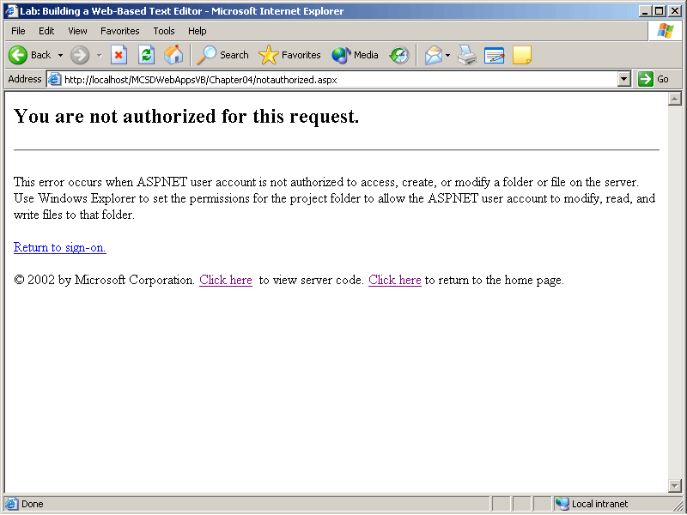
Figure 4-26. The NotAuthorized.aspx Web form
To create the Not Authorized Web form
- Add a new Web form to the project, and name it NotAuthorized.aspx.
- Switch to HTML mode, and add the following HTML to the Web form:
- <h2>You are not authorized for this request.</h2>
- <p>
- This error occurs when ASPNET user account is not authorized to access ,
- create, or modify&nbsp;a folder or file on the server. Use Windows
- Explorer to set the permissions for the project folder to allow the ASPNET
- user account to modify, read, and write files to that folder.
- </p>
<a href="SignOn.aspx">Return to sign-on.</a>
Review
The following questions are intended to reinforce key information presented in this chapter. If you are unable to answer a question, review the appropriate lesson and then try the question again. Answers to the questions can be found in the appendix.
- What is the main difference between the Button server control and the Button HTML control?
- How do you get several RadioButton controls to interoperate on a Web form so that only one of the RadioButton controls can have a value of True/true at any given time?
- Why does ASP.NET perform validation on both the client and the server?
- What types of validation would you use to verify that a user entered a valid customer number?
- What is wrong with the following line of code?
Visual Basic .NET
Server.Transfer("Default.htm")
Visual C#
Server.Transfer("Default.htm");
- Why can’t you open a new browser window from within server code?

